**GACCE 2025: Auckland**

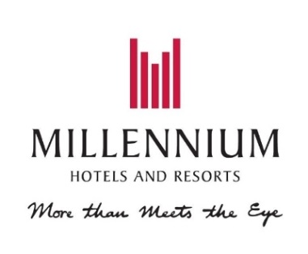

**

**GRAND MILLENNIUM, AUCKLAND**

*71 Mayoral Drive, Auckland*

Grand Millennium Auckland strives to provide you with a superior experience through excellent service and attention to detail. All of the 452 stylish rooms and suites at our hotel, combine smart design, chic decor, floor to ceiling windows for natural light and modern amenities to ensure you have a comfortable stay. This iconic hotel continues to be recognised as one of the best hotels in Auckland.

The Grand Millennium is a 25-minute walk from the conference venue (OGGB).

**酒店距离会议会场（奥克兰大学OGGB）需步行 25 分钟**

**BOOKING DETAILS**

These rates are room only, per room per night and are subject to availability. A 24hr cancellation policy is applied. The rates include complimentary unlimited Wi-Fi per day.

|  |  |
| --- | --- |
| Room Type | Room Only (incl. GST) |
| Superior Room | 10% OFF BEST AVAILABLE RATE |
| Deluxe Room | 10% OFF BEST AVAILABLE RATE |
| Club Room | 10% OFF BEST AVAILABLE RATE |
| Junior Suite | 10% OFF BEST AVAILABLE RATE |
| M Suite | 10% OFF BEST AVAILABLE RATE |
| Superior Accessible Room | 10% OFF BEST AVAILABLE RATE |

**Booking dates:** Thursday 14 – Tuesday 19th August 2025

To book online, please click on the following link [GRAND MILLENNIUM](https://www.millenniumhotels.com/en/bookings/?city=auckland&hotelcode=14674&checkin=2025-08-14&checkout=2025-08-19&promocode=GACCE25&discountcode=&groupcode=&AAA=false&AARP=false&GOV=false&Accessible=true&adults=1&children=0&rooms=1&childrenAges=&viewrates=rooms)

To book via email or phone, please quote the Promo Code: **GACCE25**

+64 9 366 3000 or grandmillennium.auckland@millenniumhotels.co.nz

Website: [Grand Millennium Auckland](https://url.au.m.mimecastprotect.com/s/mrwqC3QNqKIPMNR3Tgov-u?domain=millenniumhotels.com/)

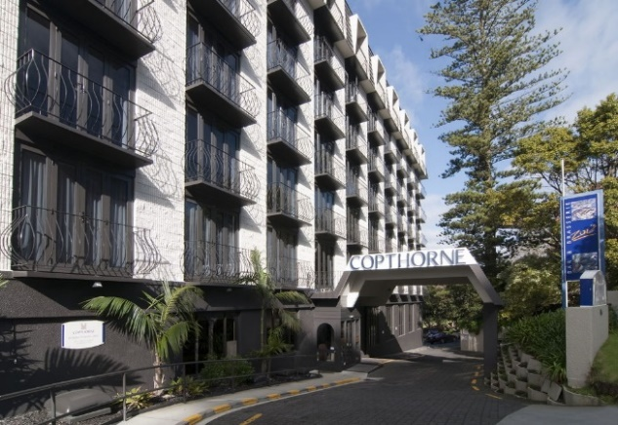 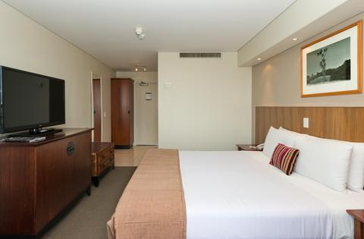

**COPTHORNE HOTEL AUCKLAND CITY, AUCKLAND**

*150 Anzac Avenue, Auckland*

Simple, sophisticated, and designed for comfort. Copthorne Hotel Auckland City is centrally located, making it the perfect base to explore the city and attend conferences. The conference venue is just five minutes’ walk away. The hotel has 106 guest rooms and 4 luxury suites. For hunger pangs and nightcaps, there’s Jimmy Cook’s Kiwi Kitchen. A casual spot serving up some of the most delicious local fare with an extensive wine, beer, and cocktail menu.

Copthorne Auckland Hotel is a 7-minute walk from the conference venue (OGGB).

**酒店距离会议会场（奥克兰大学OGGB）需步行 7 分钟**

**BOOKING DETAILS**

These rates are room only, per room per night and are subject to availability. A 24hr cancellation policy is applied. The rates include complimentary unlimited Wi-Fi per day.

|  |  |
| --- | --- |
| Room Type | Room Only (incl. GST) |
| Superior Room | 10% OFF BEST AVAILABLE RATE |
| Superior Accessible Room | 10% OFF BEST AVAILABLE RATE |
| Superior Harbourview Room | 10% OFF BEST AVAILABLE RATE |
| Junior Suite | 10% OFF BEST AVAILABLE RATE |

**Booking dates:** Thursday 14 – Tuesday 19th August 2025

To book online, please click on the following link [COPTHORNE](https://www.millenniumhotels.com/en/bookings/?hotelcode=13510&checkin=2025-08-14&checkout=2025-08-19&discountcode=&groupcode=&promocode=GACCE25&adults=1&children=0&rooms=1&AAA=false&AARP=false&GOV=false&Accessible=true&noPromo=false&hasCode=false&offername=&viewrates=Rooms)

To book via email or phone, please quote the Promo Code: **GACCE25**

+64 9 379 8509 or Copthorne.aucklandcity@millenniumhotels.co.nz

Website: [Copthorne Hotel Auckland City](https://www.millenniumhotels.com/en/auckland/copthorne-hotel-auckland-city/)

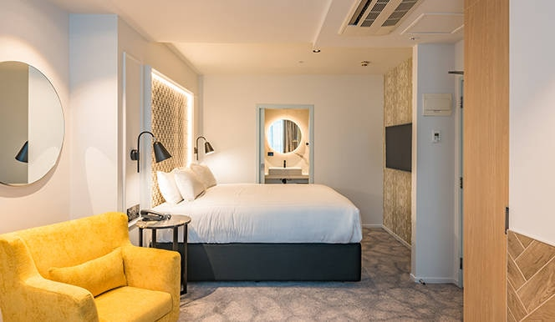

**Airedale Boutique Suites, AUCKLAND**

*380 Queen St, Auckland 1010*

Located on Auckland’s central Queen Street, Airedale Boutique Suites is in the heart of Auckland city’s central business district. As a guest, you will enjoy having some of Auckland’s top entertainment, shopping and eating places right on your doorstep. Proudly New Zealand owned and operated, and an industry leader for sustainability in the hotel and hospitality sectors. Scenic Hotel Group are Toitū carbon reduce certified (ISO 14064-1), more information found [scenichotelgroup.co.nz/about-us/sustainability/toitu/](https://www.scenichotelgroup.co.nz/about-us/sustainability/toitu/)

Airedale Boutique Suites is a 13-minute walk from the conference venue (OGGB).

**酒店距离会议会场（奥克兰大学OGGB）需步行 13分钟**

**BOOKING DETAILS**

Rates are per room per night and subject to availability.

Free and unlimited Wi-Fi is included. Valet parking available for $45 per night.

Cancellation is 4pm on the day of arrival and a credit card is required to guarantee your booking.

|  |  |
| --- | --- |
| Room Type | Room Only (incl. GST) |
| Available Rooms | $299 FIXED RATE |

Booking dates: Thursday 14 – Tuesday 19th August 2025

To book, please provide the Reservations team with booking code: GACCE25

To book online, please click on the following link [AIRDALE BOUTIQUE SUITES](https://reservations.scenichotelgroup.co.nz/107082?adults=2&children=0&rooms=1&datein=08/14/2025&dateout=08/19/2025&hotelid=107082&identifier=GACCE25#/accommodation/room) to receive a discount over the dates of this event.

Email: [reservations@scenicgroup.co.nz](mailto:reservations@scenicgroup.co.nz)

Phone: 0800 69 69 63