**GACCE 2025: Queenstown**

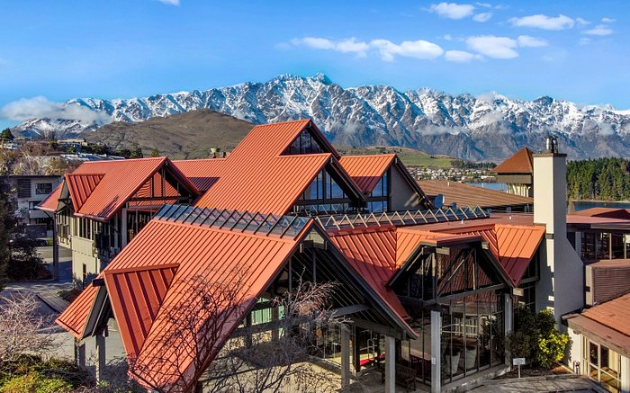 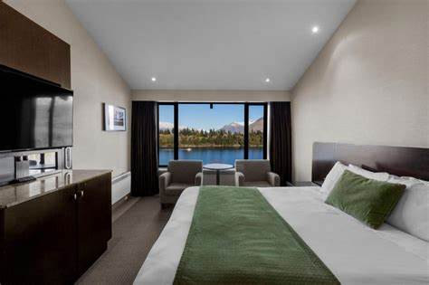

**COPTHORNE HOTEL AND RESORT, QUEENSTOWN**

*Corner Frankton Rd and Adelaide St, Queenstown*

Our accommodation in Queenstown is nestled within our garden-inspired property, comprising 240 guest rooms, including 6 Suites and over 80 rooms that have views of Lake Wakatipu and the Remarkables mountain range.

The hotel also offers charged parking options and 2 electric vehicle charging stations. Copthorne Hotel and Resort Queenstown Lakefront is a 4-star rated hotel with a Silver Sustainable Tourism Business Award.

Copthorne Queenstown Hotel is a 19-minute walk from the conference venue (Rydges Hotel).

**BOOKING DETAILS**

These rates are room only, per room per night and are subject to availability. A 24hr cancellation policy is applied. The rates include complimentary unlimited Wi-Fi per day.

|  |  |
| --- | --- |
| Room Type | Room Only (incl. GST) |
| Superior Room | 10% OFF BEST AVAILABLE RATE |
| Superior Lakeview Room | 10% OFF BEST AVAILABLE RATE |
| Junior Suite | 10% OFF BEST AVAILABLE RATE |

Booking dates: Tuesday 12th – Friday 15th August 2025

To book online, please click on the following link [COPTHORNE](https://www.millenniumhotels.com/en/bookings/?hotelcode=13549&checkin=2025-08-12&checkout=2025-08-15&discountcode=&groupcode=&promocode=GACCE25&adults=1&children=0&rooms=1&AAA=false&AARP=false&GOV=false&Accessible=true&noPromo=false&hasCode=false&offername=&viewrates=Rooms)

To book via email or phone, please quote the Promo Code: **GACCE25**

+64 3 450 0260 or Copthorne.lakefront@millenniumhotels.co.nz

Website: [Copthorne Hotel Queenstown](https://www.millenniumhotels.com/en/queenstown/copthorne-hotel-and-resort-lakefront-queenstown/)

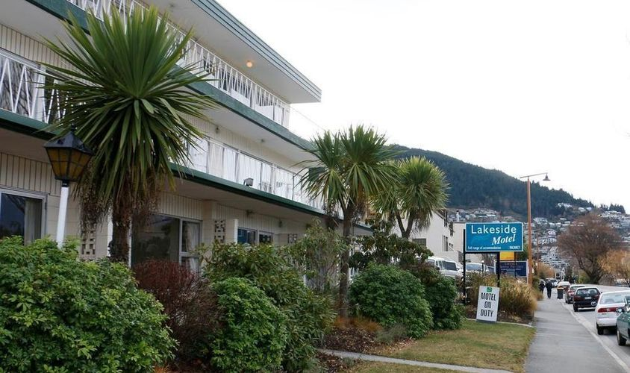

**LAKESIDE MOTEL**

*18 Lake Esplanade, Queenstown 9300*

The Lakeside Motel is one of the most popular motels in Queenstown due to its proximity to the lake, scenic views, and adventure sports. Lakeside Motel is your answer if you’re looking for a studio or family accommodation in Queenstown. All our rooms have been designed with your comfort in mind and are warm, welcoming, and affordable.

Wake up to the stunning mountain views over Lake Wakatipu without the expensive price tag!

Lakeside Motel Queenstown is a 2-minute walk from the conference venue.

**BOOKING DETAILS**

All rooms have free Wi-Fi, a TV and a shared balcony/terrace.

Booking dates: Tuesday 12th – Friday 15th August 2025

Website: [Lakeside Motel](https://vrhotels.co.nz/lakeside-motel-queenstown/)

Email: lhq.reservations@vrhotels.co.nz

Phone: (+64) 3 442 8976

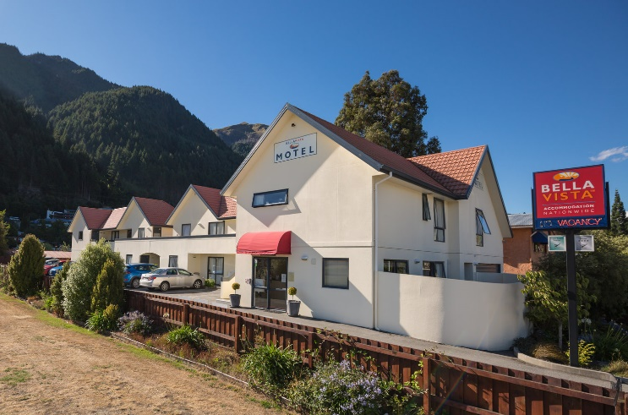 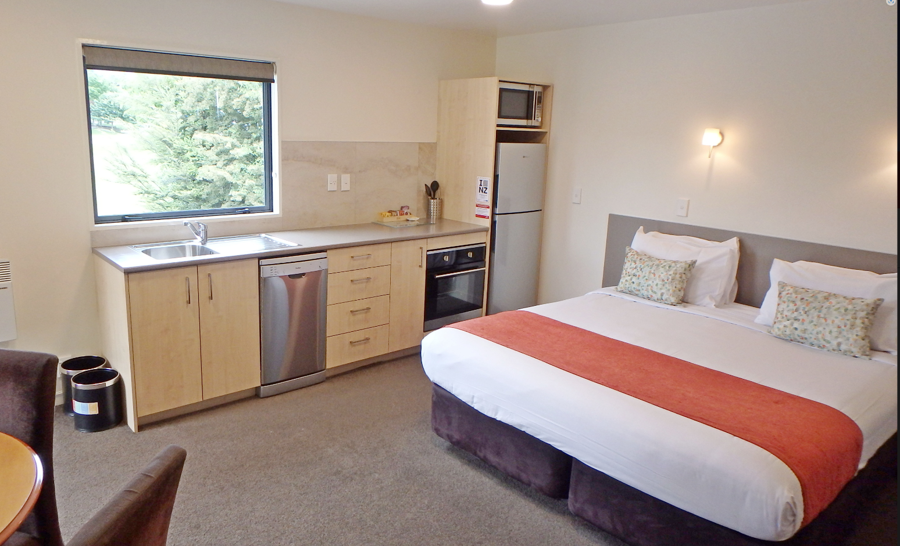

**BellaVista, QUEENSTOWN**

*36 Robins Road, Queenstown 9300*

This property has been independently assessed by Qualmark as 4 star plus quality accommodation.

From the moment you arrive at Bella Vista, you'll enjoy the convenience of being located in close proximity to the Queenstown CBD for business, shops, entertainment and other activities. At Our motel accommodation in Queenstown, we cater for all your business or recreational needs. Whilst central, the motel is also very quiet, allowing you a good night's sleep.

BellaVista Queenstown is a 17-minute walk from the conference venue.

**BOOKING DETAILS**

Wi-Fi and parking is available.

Booking dates: Tuesday 12th – Friday 15th August 2025

Website: [BellaVista](https://www.bellavista.co.nz/our-motels/queenstown)

Email: queenstown@bellavista.co.nz

Phone: (+64) 3 442 4468

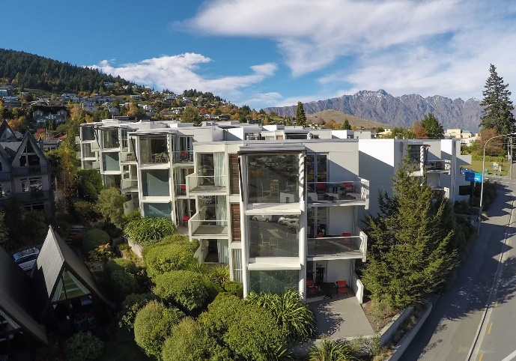 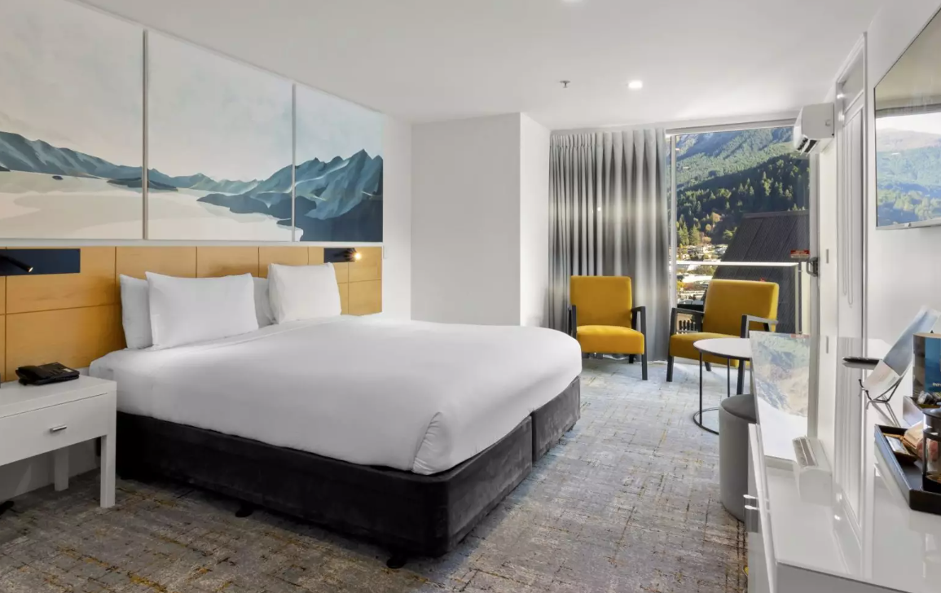

**Scenic Suites Queenstown**

*27 Stanley St, Queenstown 9300*

Our hotel rooms in Queenstown have been recently refurbished and offer the best of both worlds – contemporary hotel style Studio rooms or fully self-contained apartment style suites with the benefit of being able to enjoy all the hotel perks like an on-site restaurant and bar, room service and other hotel services.

Proudly New Zealand owned and operated, and an industry leader for sustainability in the hotel and hospitality sectors. Scenic Hotel Group are Toitū carbon reduce certified (ISO 14064-1), more information found [scenichotelgroup.co.nz/about-us/sustainability/toitu/](https://www.scenichotelgroup.co.nz/about-us/sustainability/toitu/)

Scenic Suites Queenstown is a 17-minute walk from the conference venue.

**BOOKING DETAILS**

Rates are per room per night and subject to availability. Free and unlimited Wi-Fi is included.

Cancellation is 4pm on the day of arrival and a credit card is required to guarantee your booking.

|  |  |
| --- | --- |
| Room Type | Room Only (incl. GST) |
| All available rooms | $440 FIXED RATE |

Booking dates: Tuesday 12th – Friday 15th August 2025

To book, please provide the Reservations team with booking code: GACCE25

To book online, please click on the following link [Scenic Suites QT](https://reservations.scenichotelgroup.co.nz/107089?adults=2&children=0&rooms=1&datein=08/12/2025&dateout=08/15/2025&hotelid=107089&identifier=GACCE25#/accommodation/room) to receive a discount over the dates of this event.

Email: [reservations@scenicgroup.co.nz](mailto:reservations@scenicgroup.co.nz)

Phone: 0800 69 69 63