SASEM CONFERENCE

Research Methods Workshop

Advanced Issues in Partial Least Squares   
Structural Equation Modelling (PLS-SEM)   
Using SmartPLS

# Tentative schedule and contents

Wynn Macau Hotel | July 28, 2025

|  |  |
| --- | --- |
| **Times** | **Content** |
| **14:00**  **to**  **15:30** | * Importance-performance analysis (IPMA) & SmartPLS exercise * Necessary condition analysis & SmartPLS exercise * Combined IPMA and NCA (cIPMA) & SmartPLS exercise |
| **Break** | |
| **16:00**  **to**  **17:30** | * Endogeneity and Gaussian copulas & SmartPLS exercise * Higher-order constructs & SmartPLS exercise * Moderated-mediation & SmartPLS exercise |

# Goal and overview

This ten-parts online course participants to the state-of-the-art of partial least squares structural equation modeling (e.g., Hair et al., 2022; Ringle et al., 2023; Sarstedt et al., 2021) using [the SmartPLS 4 software](http://www.smartpls.com) (Ringle et al., 2024). The first day of the course kicks of with an introduction that explains its key goals, benefits and components including the PLS-SEM Academy video-based sessions and the SmartPLS 4 software. The subsequent video-based online sessions provide a profound introduction to PLS-SEM. Participants will learn the selected advanced topics of PLS-SEM and how to apply it by means of the SmartPLS 4 software (see the tentative schedule).

# The relevance of PLS-SEM in business research

PLS-SEM is a composite-based approach to SEM, which aims at maximizing the explained variance of dependent constructs in the path model. Researchers and practitioners use PLS-SEM especially when they conduct studies on success factors and the sources of competitive advantage.

Compared to other SEM techniques, PLS-SEM allows researchers to estimate very complex models with many constructs and indicator variables. Furthermore, PLS-SEM allows to estimate reflective and formative constructs and generally offers much flexibility in terms of data requirements. The goal of PLS-SEM is the explanation of variances (prediction-oriented character of the methodology) rather than explaining covariances (theory testing via covariance-based SEM, CB-SEM; Rigdon et al., 2017). The application of the PLS-SEM method is of high interest if the assumptions of CB-SEM are violated, and the proposed cause-and-effect relationships are not sufficiently explored. An additional advantage of the PLS-SEM method is the unrestricted inclusion of latent variables in small to very complex path models that draw on either/both reflective or formative measurements models. PLS-SEM has received considerable attention in a variety of disciplines (e.g., Ali et al., 2018; Khan et al., 2019; Nitzl & Chin, 2017; Ringle et al., 2020; Sarstedt et al., 2022), which resulted in several highly cited publications (e.g., Web of Science).

# Who should attend?

This course has been designed for full-time faculty and PhD/DBA doctoral students who are interested in learning how to design their research towards more rigorous and publishable outputs that potentially survive the test of time and are more frequently read and cited. A basic knowledge of univariate and multivariate statistics and SEM techniques is helpful, but not required.

# Instructors

**Dr. Christian M. Ringle**, Professor of Management and Decision Sciences,   
Hamburg University of Technology, Germany, and James Cook University, Australia

**Christian** is a chaired Professor of Management and Decision Sciences at the Hamburg University of Technology (Germany) *and* James Cook University (Australia). His research, which has been cited more than 250,000 time (Google Scholar), focuses on management and marketing topics, method development, business analytics, machine learning, and the application of business research methods to decision making. His contributions have been published in journals such as Industrial Marketing Management, International Journal of Research in Marketing, Information Systems Research, Journal of Business Research, Journal of Service Research, Journal of the Academy of Marketing Science, Long Range Planning, and MIS Quarterly. Since 2018, Christian has been included in the Clarivate Analytics' Highly Researchers list. He regularly teaches doctoral seminars on business analytics and multivariate statistics. Christian is a co-founder and co-developer of the statistical software SmartPLS (https://www.smartpls.com).

* More information on Christian M. Ringle and his list of publications: http://www.tuhh.de/mds/team/prof-dr-c-m-ringle.html
* Google Scholar: https://scholar.google.de/citations?user=y5F176wAAAAJ&hl=de
* Email: c.ringle@tuhh.de

# Learning outcomes

This course is designed to look at the stages of research question development and theorizing together with the subsequent methodological implementation using the multivariate analysis method PLS-SEM in business and management research. The learning objectives are to (1) contribute to theory by establishing a useful PLS path model, (2) develop an in-depth methodological appreciation of the PLS-SEM approach (the nature of theoretical modelling, analytical objectives, and related statistics), (3) acquire knowledge to evaluate measurement results, and (4) understand complementary analytical techniques. Specifically, the workshop participants will understand the advanced PLS-SEM topics highlighted in the tentative schedule. In addition, the participants will be able to use the SmartPLS 4 software for their PLS-SEM analyses.

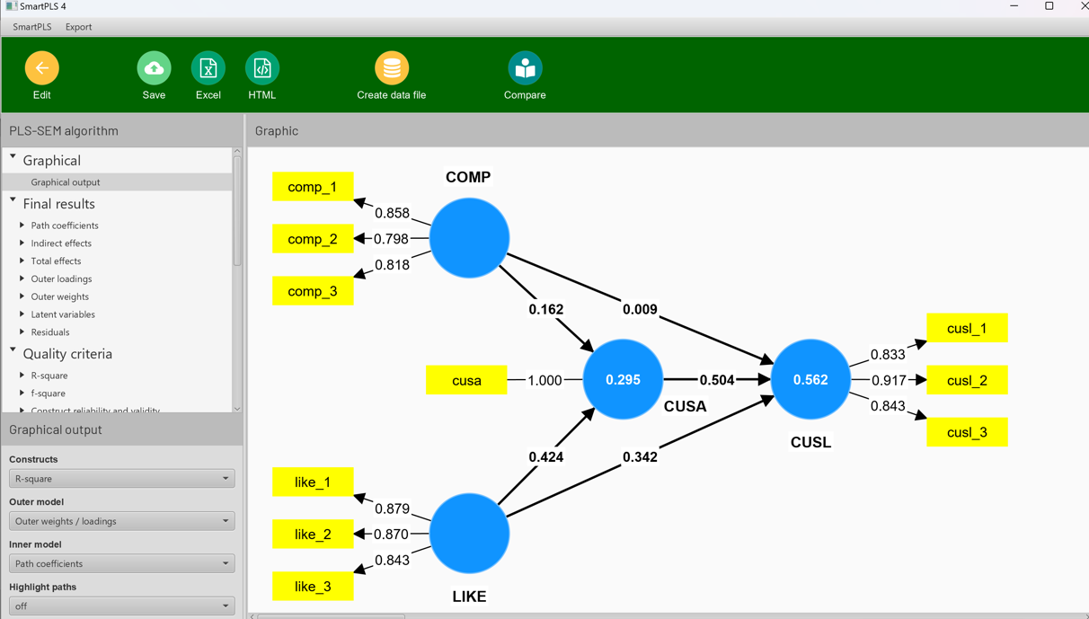

# Teaching and learning methods

* Online lectures/presentations: The sessions will cover theory and its application.
* Computer exercises use the latest SmartPLS 4 version: Specifically, theoretical explanations underlying the software procedures and practical exercises where participants will apply their learning to real-world examples provided by the instructor.
* Download and install the SmartPLS 4 software from http://www.smartpls.com before coming to the workshop (participants will receive detailed instructions shortly before the course starts)
* All participants will get a 60-days license for SmartPLS 4 Professional.
* All participants receive a course certificate.

# Teaching resources

Hair, Joseph F., G. Tomas M. Hult, Christian M. Ringle, and Marko Sarstedt (2022), A primer on partial least squares structural equation modeling (PLS-SEM) (3rd ed.). Thousand Oaks, CA: Sage Publications.

Hair, Joseph F., Marko Sarstedt, Christian Ringle, and Siegfried P. Gudergan (2024), Advanced issues in partial least squares structural equation modeling (2nd ed.). Thousand Oaks, CA: Sage Publications.

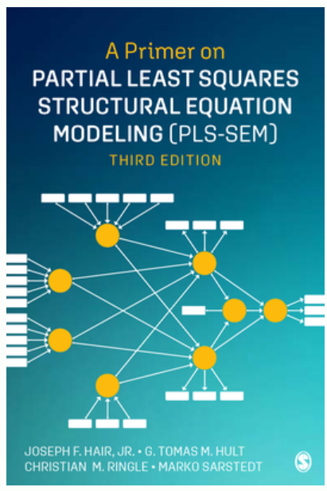 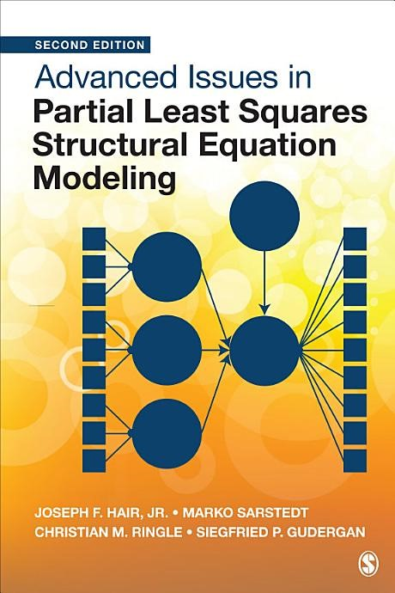

## Software

|  |  |
| --- | --- |
|  | Ringle, Christian M., Sven Wende, and Jan-Michael Becker (2024), SmartPLS 4. Bönningstedt: SmartPLS. |

# Recommended literature (only for the interested readers)

**More PLS-SEM literature and publications:** https://www.smartpls.com/documentation

* Becker, J.-M., Cheah, J. H., Gholamzade, R., Ringle, C. M., & Sarstedt, M. (2023). [PLS-SEM’s Most Wanted Guidance](https://www.emerald.com/insight/content/doi/10.1108/IJCHM-04-2022-0474/full/html). *International Journal of Contemporary Hospitality Management*, *35*(1), 321-346.
* Dul, J. (2016). [Necessary Condition Analysis (NCA): Logic and Methodology of "Necessary but not Sufficient" Causality](https://journals.sagepub.com/doi/10.1177/1094428115584005). *Organizational Research Methods, 19*(1), 10-52.
* Dul, J., Hauff, S., & Tóth, Z. (2021). [Necessary Condition Analysis in Marketing Research.](https://www.elgaronline.com/edcollchap/edcoll/9781788976947/9781788976947.00008.xml) In R. Nunkoo, V. Teeroovengadum, & C. M. Ringle (Eds.), *Handbook of Research Methods for Marketing Management* (pp. 51-72). Edward Elgar.
* Guenther, P., Guenther, M., Ringle, C. M., Zaefarian, G., & Cartwright, S. (2023). [Improving PLS-SEM Use for Business Marketing Research](https://www.sciencedirect.com/science/article/pii/S0019850123000445). *Industrial Marketing Management, 111*(May), 127-142.
* Hair, J. F., Risher, J. J., Sarstedt, M., & Ringle, C. M. (2019). [When to Use and How to Report the Results of PLS-SEM](https://doi.org/10.1108/EBR-11-2018-0203). *European Business Review, 31*(1), 2-24.
* Hair, J. F., Sarstedt, M., Ringle, C. M., & Gudergan, S. P. (2024). [*Advanced Issues in Partial Least Squares Structural Equation Modeling (PLS-SEM)*](https://www.smartpls.com/documentation/getting-started/book-on-advanced-pls-sem-issues) (2nd edition) Thousand Oaks, CA: Sage.
* Hair, J. F., Sarstedt, M., Ringle, C. M., & Gudergan, S. P. (2024). [*Advanced Issues in Partial Least Squares Structural Equation Modeling (PLS-SEM)* (2 ed.)](https://uk.sagepub.com/en-gb/eur/advanced-issues-in-partial-least-squares-structural-equation-modeling/book279526). Thousand Oaks, CA: Sage.
* Hair, J.F., Hult, G.T.M., Ringle, C. M., & Sarstedt, M. (2022).[*A Primer on Partial Least Squares Structural Equation Modeling (PLS-SEM)*](https://www.smartpls.com/documentation/getting-started/pls-sem-book)(3rd edition). Thousand Oaks, CA: Sage.
* Hauff, S., Richter, N. F., Sarstedt, M., & Ringle, C. M. (2024). [Importance and Performance in PLS-SEM and NCA: Introducing the Combined Importance-Performance Map Analysis (cIPMA)](https://www.sciencedirect.com/science/article/pii/S0969698924000195). *Journal of Retailing and Consumer Services, 78*, 103723.
* Richter, N. F., Schubring, S., Hauff, S., Ringle, C. M., & Sarstedt, M. (2020). [When Predictors of Outcomes are Necessary: Guidelines for the Combined Use of PLS-SEM and NCA](https://www.emerald.com/insight/content/doi/10.1108/IMDS-11-2019-0638/full/html). *Industrial Management & Data Systems, 120*(12), 2243-2267.
* Ringle, C. M., & Sarstedt, M. (2016). [Gain More Insight from Your PLS-SEM Results: The Importance-Performance Map Analysis](https://www.emerald.com/insight/content/doi/10.1108/IMDS-10-2015-0449/full/html)*. Industrial Management & Data Systems, 116*(9), 1865-1886.
* Ringle, C. M., Sarstedt, M., Sinkovics, N., & Sinkovics, R. R. (2023). [A Perspective on Using Partial Least Squares Structural Equation Modeling in Data Articles](https://link.springer.com/article/10.1057/s41270-023-00231-9). *Data in Brie*f, *48*(June), 109074.
* Sarstedt, M., Hair, J. F., & Ringle, C. M. (2022). ["PLS-SEM: Indeed a Silver Bullet" – Retrospective Observations and Recent Advances](https://www.tandfonline.com/doi/abs/10.1080/10696679.2022.2056488). *Journal of Marketing Theory & Practice*, *31*(3), 261-275.
* Sarstedt, M., Hair, J. F., Nitzl, C., Ringle, C. M., & Howard, M. C. (2020). [Beyond a Tandem Analysis of SEM and PROCESS: Use PLS-SEM for Mediation Analyses!](https://doi.org/10.1177%2F1470785320915686) *International Journal of Market Research, 62*(3), 288–299.
* Sarstedt, M., Hair, J. F., Pick, M., Liengaard, B. D., Radomir, L., & Ringle, C. M. (2022). [Progress in Partial Least Squares Structural Equation Modeling Use in Marketing Research in the Last Decade](https://onlinelibrary.wiley.com/doi/full/10.1002/mar.21640). *Psychology & Marketing*, *39*(5), 1035-1064.
* Sarstedt, M., Hair, J. F., Ringle, C. M., Thiele, K. O., & Gudergan, S. P. (2016). [Estimation Issues with PLS and CBSEM: Where the Bias Lies!](http://www.sciencedirect.com/science/article/pii/S0148296316304404) *Journal of Business Research*, 69(10), 3998-4010.
* Sarstedt, M., Richter, N. F., Hauff, S., & Ringle, C. M. (2024). [Combined Importance–performance Map Analysis (cIPMA) in Partial Least Squares Structural Equation Modeling (PLS–SEM): A SmartPLS 4 Tutorial](https://link.springer.com/article/10.1057/s41270-024-00325-y). *Journal of Marketing Analytics*, forthcoming.
* Sarstedt, M., Ringle, C. M., & Hair, J. F. (2022). [Partial Least Squares Structural Equation Modeling](https://link.springer.com/referenceworkentry/10.1007/978-3-319-57413-4_15). In Homburg, C., Klarmann, M., & Vomberg, A. (Eds.), *Handbook of Market Research*. Cham: Springer, 587–632.
* Sharma, P. N., Liengaard, B. D., Hair, J. F., Sarstedt, M., & Ringle, C. M. (2023). [Predictive Model Assessment and Selection in Composite-based Modeling Using PLS-SEM: Extensions and Guidelines for Using CVPAT](https://www.emerald.com/insight/content/doi/10.1108/EJM-08-2020-0636/full/html). *European Journal of Marketing*, 56(6), 1662-1677.
* Shmueli, G., Sarstedt, M., Hair, J. F., Cheah, J.-H., Ting, H., & Ringle, C. M. (2019). [Predictive model assessment in PLS-SEM: Guidelines for using PLSpredict](https://doi.org/10.1108/EJM-02-2019-0189). *European Journal of Marketing, 53*(11), 2322-2347.

# Additional References

Ali, F., Rasoolimanesh, S. M., Sarstedt, M., Ringle, C. M., & Ryu, K. (2018). An Assessment of the Use of Partial Least Squares Structural Equation Modeling (PLS-SEM) in Hospitality Research. *International Journal of Contemporary Hospitality Management*, *30*(1), 514-538.

Becker, J.-M., Cheah, J. H., Gholamzade, R., Ringle, C. M., & Sarstedt, M. (2023). PLS-SEM’s Most Wanted Guidance. *International Journal of Contemporary Hospitality Management*, *35*(1), 321-346.

Hair, J. F., Hult, G. T. M., Ringle, C. M., & Sarstedt, M. (2022). *A Primer on Partial Least Squares Structural Equation Modeling (PLS-SEM)* (3 ed.). Sage.

Hair, J. F., Sarstedt, M., Ringle, C. M., & Gudergan, S. P. (2024). *Advanced Issues in Partial Least Squares Structural Equation Modeling (PLS-SEM)* (2 ed.). Sage.

Khan, G. F., Sarstedt, M., Shiau, W.-L., Hair, J. F., Ringle, C. M., & Fritze, M. (2019). Methodological Research on Partial Least Squares Structural Equation Modeling (PLS-SEM): An Analysis Based on Social Network Approaches. *Internet Research*, *29*(3), 407-429.

Nitzl, C., & Chin, W. W. (2017). The Case of Partial Least Squares (PLS) Path Modeling in Managerial Accounting. *Journal of Management Control*, *28*(2), 137-156.

Rigdon, E. E., Sarstedt, M., & Ringle, C. M. (2017). On Comparing Results from CB-SEM and PLS-SEM. Five Perspectives and Five Recommendations. *Marketing ZFP*, *39*(3), 4-16.

Ringle, C. M., Sarstedt, M., Mitchell, R., & Gudergan, S. P. (2020). Partial Least squares Structural Equation Modeling in HRM Research. *The International Journal of Human Resource Management*, *31*(12), 1617-1643.

Ringle, C. M., Sarstedt, M., Sinkovics, N., & Sinkovics, R. R. (2023). A Perspective on Using Partial Least Squares Structural Equation Modelling in Data Articles. *Data in Brief*, *48*, 109074.

Ringle, C. M., Wende, S., & Becker, J.-M. (2024). *SmartPLS 4*.In SmartPLS. <https://www.smartpls.com/>

Sarstedt, M., Hair, J. F., Pick, M., Liengaard, B. D., Radomir, L., & Ringle, C. M. (2022). Progress in Partial Least Squares Structural Equation Modeling Use in Marketing Research in the Last Decade. *Psychology & Marketing*, *39*(5), 1035-1064.

Sarstedt, M., Ringle, C. M., & Hair, J. F. (2021). Partial Least Squares Structural Equation Modeling. In C. Homburg, M. Klarmann, & A. E. Vomberg (Eds.), *Handbook of Market Research* (pp. 1-47). Springer.