Efficient Heat Pump with Water-Sorbing Heat Exchangers [Title]

First Name SURNAME(a), Jones BERNARD(b) [Author Name]
(a) Organization, City, Zip code, Country, e-mail [Institution Affiliations]
(b) Organization, City, Zip code, Country, , e-mail [Institution Affiliations]

ABSTRACT
This research introduces an integrated heat exchanger with desiccant coating, named as water-sorbing heat exchanger (WSHE). When it is used as evaporator, air is cooled down by evaporation of refrigerant meanwhile dehumidified by the desiccant, the evaporation temperature could thus be controlled at about 15 ºC. When it is used as a condenser, the desiccant could be regenerated by condensing heat, heat transfer in condenser will be enhanced significantly due to this desorption process, thereby the condensing temperature is reduced to 40-45 ºC. By using a switch valve, refrigerant flow could be changed, thus the function of evaporator and condenser could be changed. The air flow could be also switched to fulfill the function of cooling-dehumidification or heating-humidification for space. Thus desiccant dehumidification will be fully undertaken by waste heat-condensing heat partly, the 40% cooling load will be handled as free. The remaining 60% sensible cooling load will be handled by high temperature evaporation. The desiccant is the key for this air handling unit, which should be regenerated with 30 ºC temperature difference. A packaged desiccant DX heat pump (DDX HP) by replacing ordinary fin-tube coils with WSHE, which could distinctly and simultaneously treat the sensible heat load and latent heat load. Experimental results showed that its thermodynamic COP was as high as 7.14 under the summer conditions per IOS 5151:1994, while its system COP is 6.2.
KEYWORDS: Water-sorbing heat exchanger, Heat pump, Desiccant [3~6 Keywords]

1. INTRODUCTION
Space cooling and heating need nearly 30% electricity consumptions worldwide, heat pumps have been widely used for buildings, at most for residential applications. Duo to the demands of both sensible load and latent load, air conditioning usually is operated with the function of dehumidification, for which super-low evaporation temperature is needed to yield evaporator surface temperature be lower than the dew point. Independent temperature and humidity control have been thought as a reasonable way to get high COP of sensible cooling with high evaporation temperature, but it need an independent desiccant dehumidification unit, which may need additional heat for regeneration.
As condensing heat is usually rejected to the ambient, if it could be used as a heat source for the regeneration of the desiccant, then the energy dissipation to the ambient will be greatly reduced, dehumidification will be energy-free.
2. HEAT PUMP BY USING WATER-SORBING HEAT EXCHANGERS
A novel vapor compression heat pump has been proposed recently as shown in Fig. 1a&b, in which solid/liquid desiccant is directly coated/sprayed to the outside surface of a conventional evaporator and condenser to forme the so-called WSHE (Fig.1c). When process air passes through the desiccant coated evaporator, the refrigerant inside can handle the sensible load while outside the coated desiccant realizes the removing of latent load. In this case, the processed air leaving the evaporator satisfies the requirement for supply air without overcooling or reheating (Fig.1d). On the other hand, adsorbent/absorbent can be regenerated in a desiccant coated condenser.
Composite silica-gel-supported lithium chloride (CSGL) was selected as desiccant-needed, which adsorption capacity difference between a typical cooling/adsorption phase (80% RH) and a condensation/desorption phase (30% RH) is 0.34 kg kg⁻¹, more than twice that of silica gel due to the combination of capillary condensation and solution absorption (Fig.1f). In addition, the water-borne compound adhesive used as a binder. Meanwhile, it is easier to avoid corrosion or carryover of liquid droplets by controlling the salt content [2] and to prevent saturation or leakage by adjusting the duration of the moisture uptake process. The optimal coating thickness is approximately 10% of fin space based on our experience.
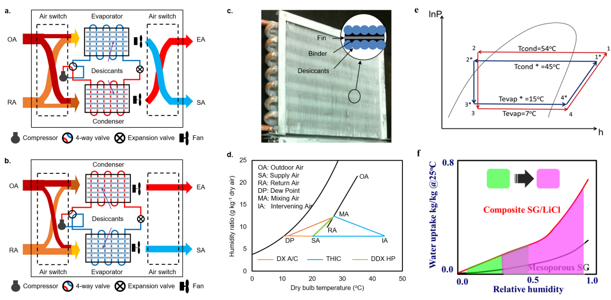
Figure 1: Schematics of DDX HP: working principle (a,b), photo of WSHE (c), air handling process (d), VC loop (e) and effects of WSHE on adsorbent (f).

A packaged desiccant-enhanced DX heat pump by replacing ordinary fin-tube coils with WSHEs has been designed to demonstrate the proof of concept. Experimental results showed that the evaporating temperature is increased from 5-7 ºC to 15-20 ºC, and the condensing temperature is reduced from 50-55 ºC to 40-45 ºC (Fig.1e). Its thermodynamic COP was as high as 7.14 under the summer conditions, while its system COP is 6.2. According to our knowledge, it is the first time that an approach can offer more comfortable supply air, doubled energy efficiency and 50% load capacity improvement, and most importantly, without sacrificing compactness like DX A/C.
3. CONCLUSIONS
The proposed WSHE can independently handle sensible and latent loads at the same time, which opens up the possibility of achieving ultrahigh efficiency for a broad range of temperature- and humidity-control applications.
ACKNOWLEDGEMENT
This work was supported by the National Natural Science Foundation of China (No. 51521004).
REFERENCES
[1] Y.D. Tu, R.Z. Wang, T.S. Ge, X. Zheng, 2017, Comfortable, high-efficiency heat pump with desiccant-coated, water-sorbing heat exchangers, Scientific Reports, 7, 40437.
[2] Gordeeva, L.G., Aristov, Yu.I., 2012, Composites ‘salt inside porous matrix’ for adsorption heat transformation: a current state-of-the-art and new trends. International Journal of Low-Carbon Technologies. 7, 288-302.

