Title of the Abstract
First Author^{1#}, Second Author², and Third Author¹ (use First name Surname)
¹ School of Civil Engineering, Central South University, No. 22 Shaoshan South Road, Changsha 410075, China, first.author@csu.edu.cn
² School of Civil Engineering, Wuhan University, Luojia Hill, Wuhan 430072, China
# Corresponding author; underline the presenting author

ABSTRACT: Contributors to ICFG 2027 are required to submit a one-page abstract electronically by October 31, 2026.
The abstract must include the full names and affiliations of all authors. For joint authorship, underline the name of the author who will present the work at the conference. Abstracts can only be accepted on the understanding that the work will be presented at the conference.
The abstract must be written in English using 10-point Times New Roman, justified, with the heading ABSTRACT in bold. The abstract must not exceed 200 words. One or two figures may be included. All content must fit on one page.
The abstract must be submitted through the submission system on the conference website.
Keywords: 3-5 words.
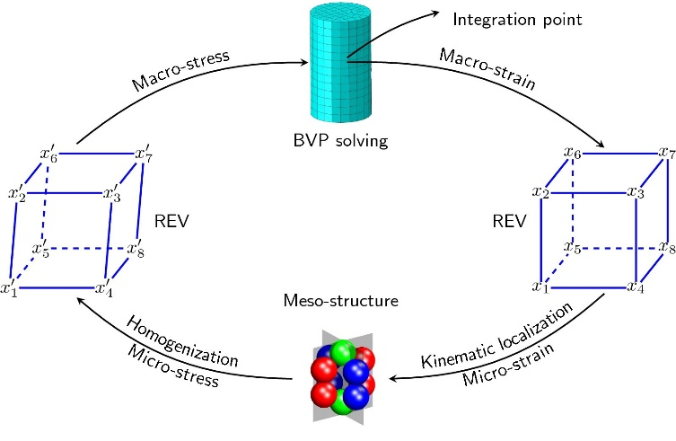
Fig. 1 Illustration of the proposed method
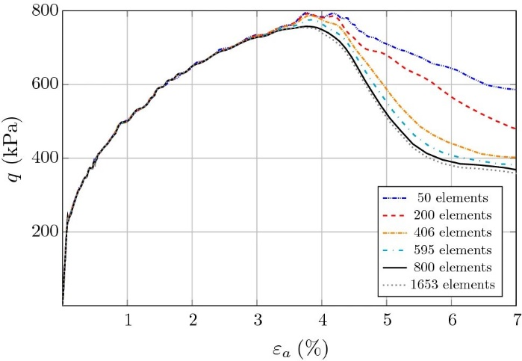
Fig. 2 Deviatoric stress evolution
(For further information, please contact the Secretariat: icfg2027@csu.edu.cn)

