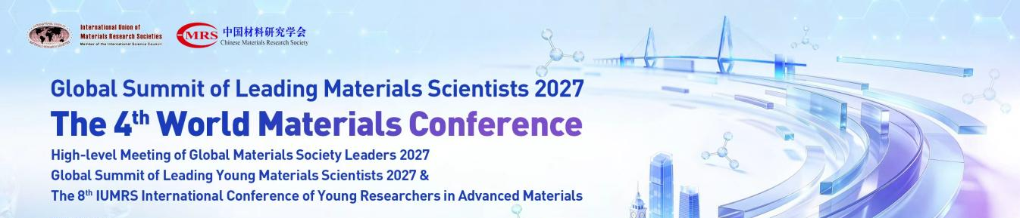
INVITATION LETTER
Dear Professor ______,
Greetings!
The World Materials Conference (WMC), organized by the Chinese Materials Research Society (C-MRS), is a leading international academic conference focusing on the latest frontiers and developments in materials science and technology worldwide.
The 4th World Materials Conference will be held on January 24–27, 2027, at the Hainan International Convention & Exhibition Center, China. The conference will also include the Global Summit of Leading Materials Scientists 2027, High-level Meeting of Global Materials Society Leaders 2027, Global Summit of Leading Young Materials Scientists 2027, and the 8th IUMRS Young Scientist Conference. Conference website: https://4thwmc.scimeeting.cn/
In recognition of your outstanding contributions in the field of ________, we sincerely invite you to attend the 4th World Materials Conference and deliver an invited presentation on ________.
We greatly appreciate your support and look forward to your participation.
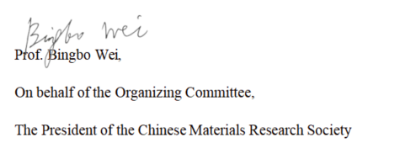
Sincerely,

