Title of your extended abstract (TNR, Bold 14pt centered)

Author, A¹, Author, B², and Author, C³ (TNR 12pt centered)

¹Institution 1(TNR 12pt centered)
²Institution 2 (TNR 12pt centered)
³Institution 3 (TNR 12pt centered)
E-mail (corresponding author)

(Note: the length of extended abstract is no more than 2 pages)

Abstract (headlines: TNR Bold, 12pt)
The extended abstract may include the title, author(s) introduction, material and methods, results and discussion, conclusion and references. The manuscript should be prepared on an A4-sized paper with 25 mm margins on all sides and typed with single spacing using size 12 Times New Roman font.

Example on the format of Table
Table 1. Caption heading for a table should be placed at the top of the table and within table width.
(Use “time news roman” font, size 10pt, No spacing after table title)
 | A | B | C | D
A | Aa | Ab | Ac | Ad
B | Ba | Bb | Bc | Bd
C | Ca | Cb | Cc | Cd
D | Da | Db | Dc | Dd
E | Ea | Eb | Ec | Ed

Example on the format of Figure
Please prepare the figures in high resolution (300 dpi) images. Figure captions should be in 10pt “Time News Roman” font, bold, centered. When applicable, the texts in graphs, illustrations or images should be set in 8pt “Time News Roman” font.
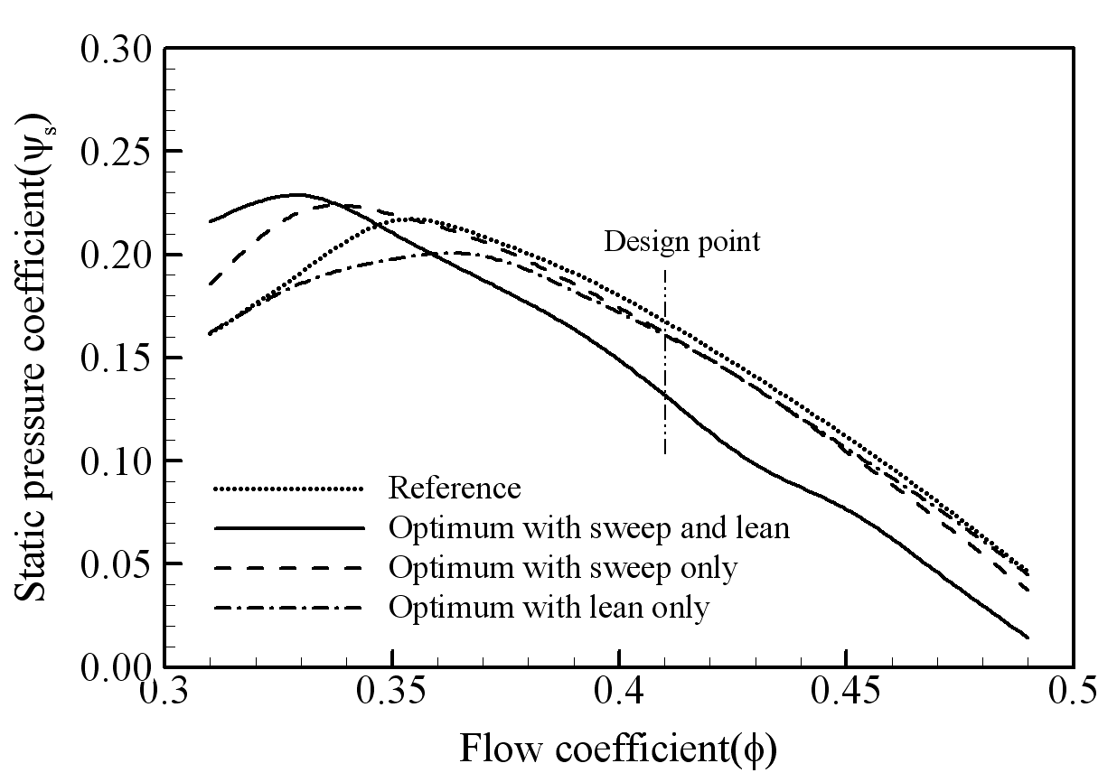
Figure 1. The caption heading for a figure should be placed below the figure and within figure/illustration width. (Use “Time News Roman” font, size 10pt, no spacing between title and figure)

Footnotes
Footnotes are denoted by a character superscript in the text b.

References (headlines: TNR Bold, 12pt)
References should be listed arranged in alphabetical order beginning with the author’s names and initials, followed by the year of publication, title of periodical, volume and page.

b Just like this one.

