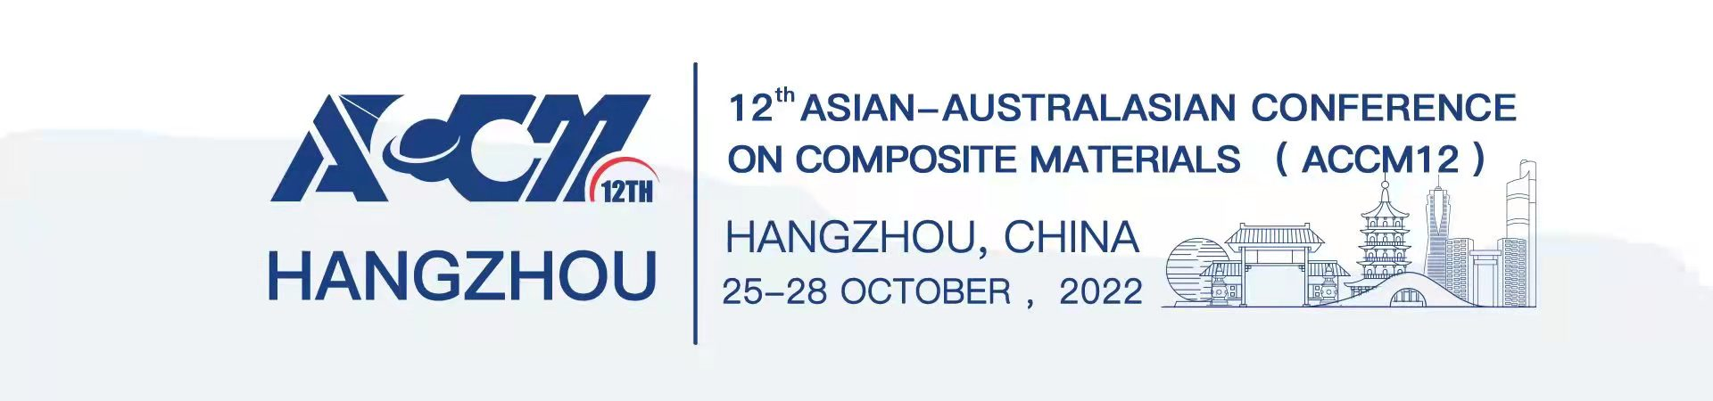

Application Form of Refundment

Payment Account Information
Name of Participant
Affiliation
Payment Amount | (RMB) or (USD)
Refund Reason | 1. Cancellation; 2. Change from Online to Onsite  3. Change from Onsite to Online;
Refund Amount | (RMB) or (USD)
Refund Account Information
Bank User name
Full Name of Receiving Bank
Bank Account
Contact Number

Signature:
Date:
Notes:
Please send the Application Form of Refundment to the email composite@zju.edu.cn.
The committee of ACCM12 will process your request in 5 working days.
For more details about Cancellations, Changes & Substitutions Policy,
Please visit the official website www.accm12.net.

