TITLE
Name¹, Name^{2*}
(1. Affiliations of Author, City Postcode, Country; 2. Affiliations of Author, City Postcode, Country)
*Email:
Abstract: This document is a WORD template and list of instructions that provides the basic guidelines for preparing an extended abstract. The abstract itself should be concise and may include the objectives, methodology, results and the conclusion of the study.
Keywords: keywords1; keywords2;…

1 Introduction
Please use this template and following the guideline in preparation of your extended abstract^{[1-4]}. All abstracts must be submitted electronically in one of the following formats: *.doc or *.docx.

2 Methodology
2.1 Subtitle
The title of the extended abstract should be placed at the top of the page with a single column. Use 22-point bold, capital first letter for the title in Times New Roman.10.5-point Times New Roman (italic) characters for author names and 7.5-point Times New Roman characters for affiliations. * please mark the corresponding author with an asterisk.
2.2 Subtitle
10.5-point Times New Roman characters for the body text.

3 Results and Discussions
3.1 Subtitle
All paragraphs should be fully justified. There should be no empty lines between paragraphs in the same section. Leave an empty line between the last paragraph of this section and the heading of the subsequent section.
Each section needs a heading. All headings should be flushed to the left. Use 10.5-point Times New Roman (bold) characters and the first letter of headings should be in uppercase.
3.2 Subtitle
All tables should be horizontally centred across the column, with their headings centrally placed above the table.
All figures should be horizontally centred with their captions below the figure and centrally justified. There is no restriction on the type of font in figures. However, the size of the characters must be legible (not smaller than size ~9).

Tab.1 Table of important data
Items | X | Y | Z
A | 1 | 2 | 3
B | 4 | 5 | 6
Drawings, graphs and charts should be embedded in the document as images.
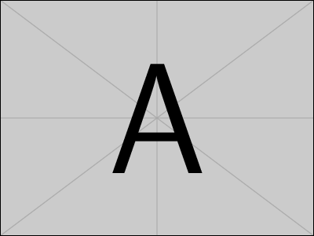
Fig.1 An example figure
Equations should be flushed right and numbered according to the following example:
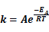 | (1)
4 Conclusions
This is the template for the two-page extended abstract. The organizers would be grateful if you could follow this template in preparing your extended abstract.

References:
- Vázquez G, Rodríguez-Bona C, Freire S, et al. Acetosolv Pine Lignin as Copolymer in Resins for Manufacture of Exterior Grade Ply Woods. Bioresource Technology, 1999, 70:209-214.
- Pearson D S, Shurpik A. Universal Waste Disposal System. USA: USP 3 843 522, 1974-10-22.
- Brydson J A. Rubbery Materials and Their Compounds. London: Elsevier Science Ed, 1994.
- Gruter G.DSM’s lovacat homogeneous catalyst system for high temperature solution copolymerizations. Polymers in Transition Proceedings.Houston, USA: The Catalyst Group, 1997.35.

