Title of the CORPES2023 Abstract (Template and Guidelines for Preparation of Abstracts)

Z-T. Zhang^{1,2}, B. Wang², B-J. CORPES2023¹

¹Beijing National Laboratory for Condensed Matter Physics, and Institute of Physics, Chinese Academy of Sciences, Beijing, 100190, Peopleʼs Republic of China

²University of Chinese Academy of Science, Beijing, 100049, Peopleʼs Republic of China

The text should be prepared in English using MS Word formats. The official language of the conference is only English. Note that the abstract page with all the information should not occupy more than one full A4 page (margins: top, bottom, and left – 2.5 cm, right – 2.5 cm). The title should be written in “Title Case” (Capitalize the first letters of all the words except the conjunctions such as “and”, “or”, “at”, “in”, “for”, “the”) with 12-point bold font Times New Roman, 1.5 line spacing. Next line – author(s) name(s) (1.5 line spacing) and affiliation(s) (1.0 line spacing with italic font). The next line should be blank. After this line abstract text starts with justified 12-point font Times New Roman, 1.0 line spacing. If your abstract includes table and/or figure, place it accordingly such as Fig. 1. Please pay attention that all the text is legible and figure is saved with high resolution. Color figures are also welcome. Caption text font is Times New Roman 11 pt. and caption title (Fig. 1) is bold face.
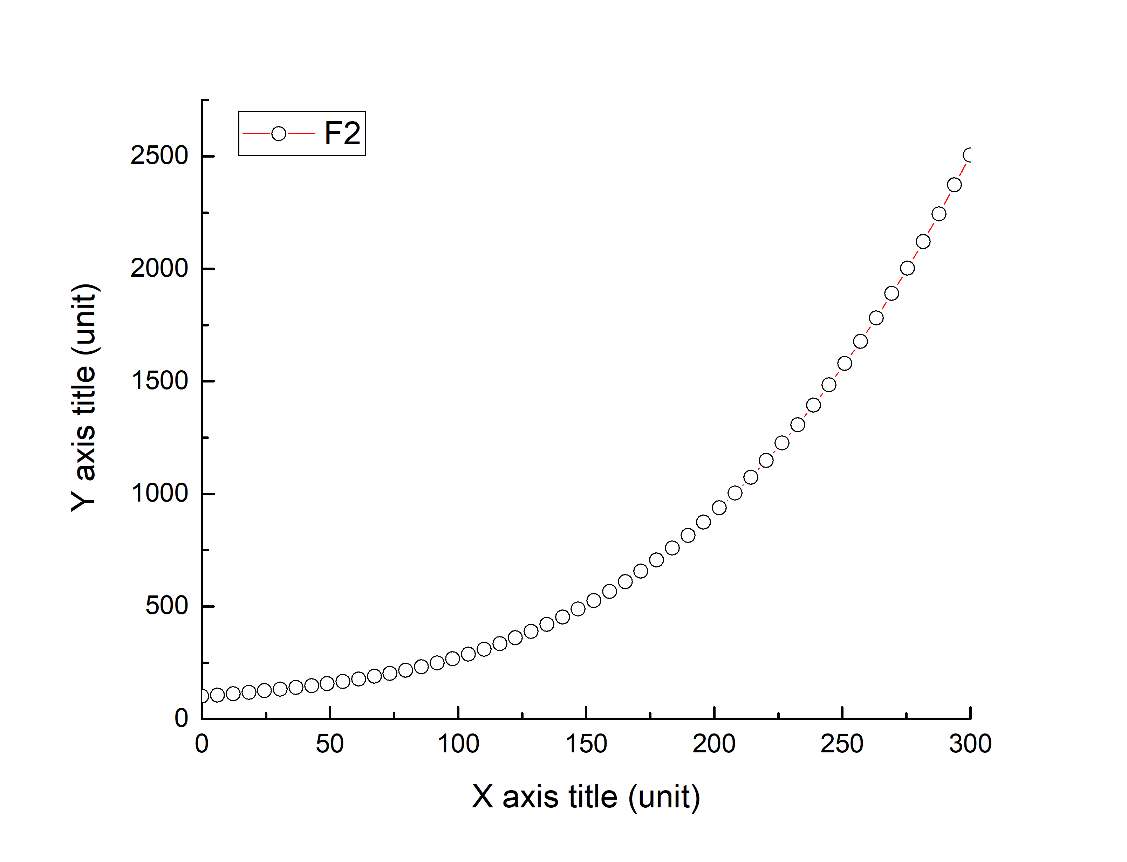
Fig. 1: Caption goes here… (Times New Roman, 11pt, italic).
References can also be given in the abstract [1]. Abstract text is allowed to flow around the graph.

References
[1]. B. J. Author, Phys. Rev. X 20, 000000 (2018).
*The CORPES 2023 will not issue procceding.

