样本格式（未注中文字体：宋体；所有西文字体和复杂文种：Times New Roman）
页面：页面的边距为距上边缘 30 毫米，距下边缘、左边缘和右边缘 20 毫米。
长水口吹氩生成微小气泡工业实验研究
楷体 四号
21号
刘建华¹⁾，李 巍¹⁾，何 杨¹⁾，苏晓峰¹⁾，张 杰²⁾，常芙蓉¹⁾
六号
1) 北京科技大学高效轧制与智能制造国家工程研究中心, 北京 100083 2) 北京科技大学冶金与生态工程学院, 北京 100083
黑体 小五
摘 要 在连铸生产中采用大流量长水口吹氩，并采用“冷钢片沾钢法”沾取中间包钢液试样，成功沾取了中间包钢液中微小氩气泡。冷钢片沾样表面气泡为中间包上部钢/渣界面和炉渣中氩气泡，尺寸主要位于1.0~3.0 mm，但该尺寸不能反映中间包钢液内部长水口吹氩生成气泡，冷钢片沾样内部气泡为钢液内部长水口吹氩生成的气泡。结合扫描电镜和共聚焦显微镜对沾取试样内部气泡形貌、尺寸和数量进行了分析，结果表明大部分气泡为独立圆形气泡，偶见少量粘连和聚合气泡；钢液内部氩气泡尺寸主要位于100~1000 μm，平均尺寸为500 μm左右；气泡在长水口出口及其下方较为弥散，气泡数量可达15.2 cm⁻²。采用扫描电镜结合能谱分析，发现部分气泡内粘附有夹杂物，有些气泡粘附多个夹杂物；气泡粘附Al₂O₃夹杂物的几率高于粘附CaO(‒MgO)‒Al₂O₃‒SiO₂复合夹杂物的几率。
小五
关键词 气泡；夹杂物；中间包；长水口；吹氩
分类号 TF769.4
小三
Industrial experimental study on the formation of microbubbles by argon injection into ladle shroud
五号斜体
Jianhua Liu¹⁾, LI Wei¹⁾, HE Yang¹⁾, SU Xiao-feng¹⁾, ZHANG Jie²⁾, CHANG Fu-rong¹⁾
六号
1） National Engineering Research Center for Advanced Rolling and Intelligent Manufacturing, University of Science and Technology Beijing, Beijing 100083, China
2） School of Metallurgical and Ecological Engineering, University of Science and Technology Beijing, Beijing 100083, China
小五加粗
ABSTRACT Using bubbles to remove inclusions in steel is rapidly becoming a popular method for refining. Fine bubbles are thought to be more effective on inclusion removal than big bubbles. The fine bubbles can be formed in molten steel using the argon injection into ladle shroud technology. There are two stages during the formation of fine bubbles in ladle shroud: bubble detachment from wall orifice and detached bubbles splitting into smaller ones in turbulent steel. Many reports have been published on the water model of the argon injection into ladle shroud technology, but industrial experimental research is in its early stage. In this study, high argon flow was injected into a ladle shroud and adopted in continuous casting production to produce fine argon bubbles in a tundish. The bubbles were captured by dipping a cold steel sheet into molten steel. The captured bubbles at the surface of a hot-dipped steel sheet, with a size of 1.0–3.0 mm, characterized the argon bubbles at steel/slag interface and slag phase in the upper part of a tundish rather than those inside molten steel in tundish. The bubbles inside molten steel in tundish were characterized by the captured bubbles in the interior of a hot-dipped steel sheet, and their morphology, size, and number were analyzed using scanning electron microscopy and confocal microscopy. The bubbles inside molten steel in tundish have a spherical shape and occasionally adhere to each other. These bubbles rang in size from 100 to 1000 μm, with an average of 500 μm. They are dispersed at the exit of a ladle shroud in its lower position, with a density of 15.2 cm^{–2}. Moreover, it was observed that a bubble could adhere to inclusion, even multiple inclusions for part of bubbles. Bubbles adhered more strongly to Al₂O₃ inclusions than that to CaO(‒MgO)‒Al₂O₃‒SiO₂ complex inclusions.
小五
小五加粗
小五
KEY WORDS bubble; inclusion; tundish; ladle shroud; argon injection
1. 引言
五号
等线五号
气泡去除钢中夹杂物具有明显优势[1-2]。气泡密度低，尺寸一般较夹杂物大，在钢液中上浮速度快；夹杂物为非金属物质，大多与钢液不润湿，夹杂物与气泡碰撞后可以粘附于气泡而快速上浮去除。
2. 实验方法
黑体五号加粗
2.1 长水口吹氩方法
现代钢铁连铸生产中，钢包中钢液经过钢包下方连接钢包与中间包的长水口流入中间包进行连铸，长水口隔绝了钢液与空气的接触，发挥了良好的保护浇注作用（图1）。钢液快速通过长水口时，在长水口与钢包底部滑动水口连接的接缝处产生较大负压，容易抽吸空气进入长水口内，造成钢水二次氧化；因此现代连铸生产中一般在长水口与滑动水口连接处设置吹氩装置，吹入氩气，抑制空气的吸入。本实验开展所在钢厂实际生产过程中为了防止吹氩量过大及节省成本，吹氩量控制在1.0 m³·h⁻¹。
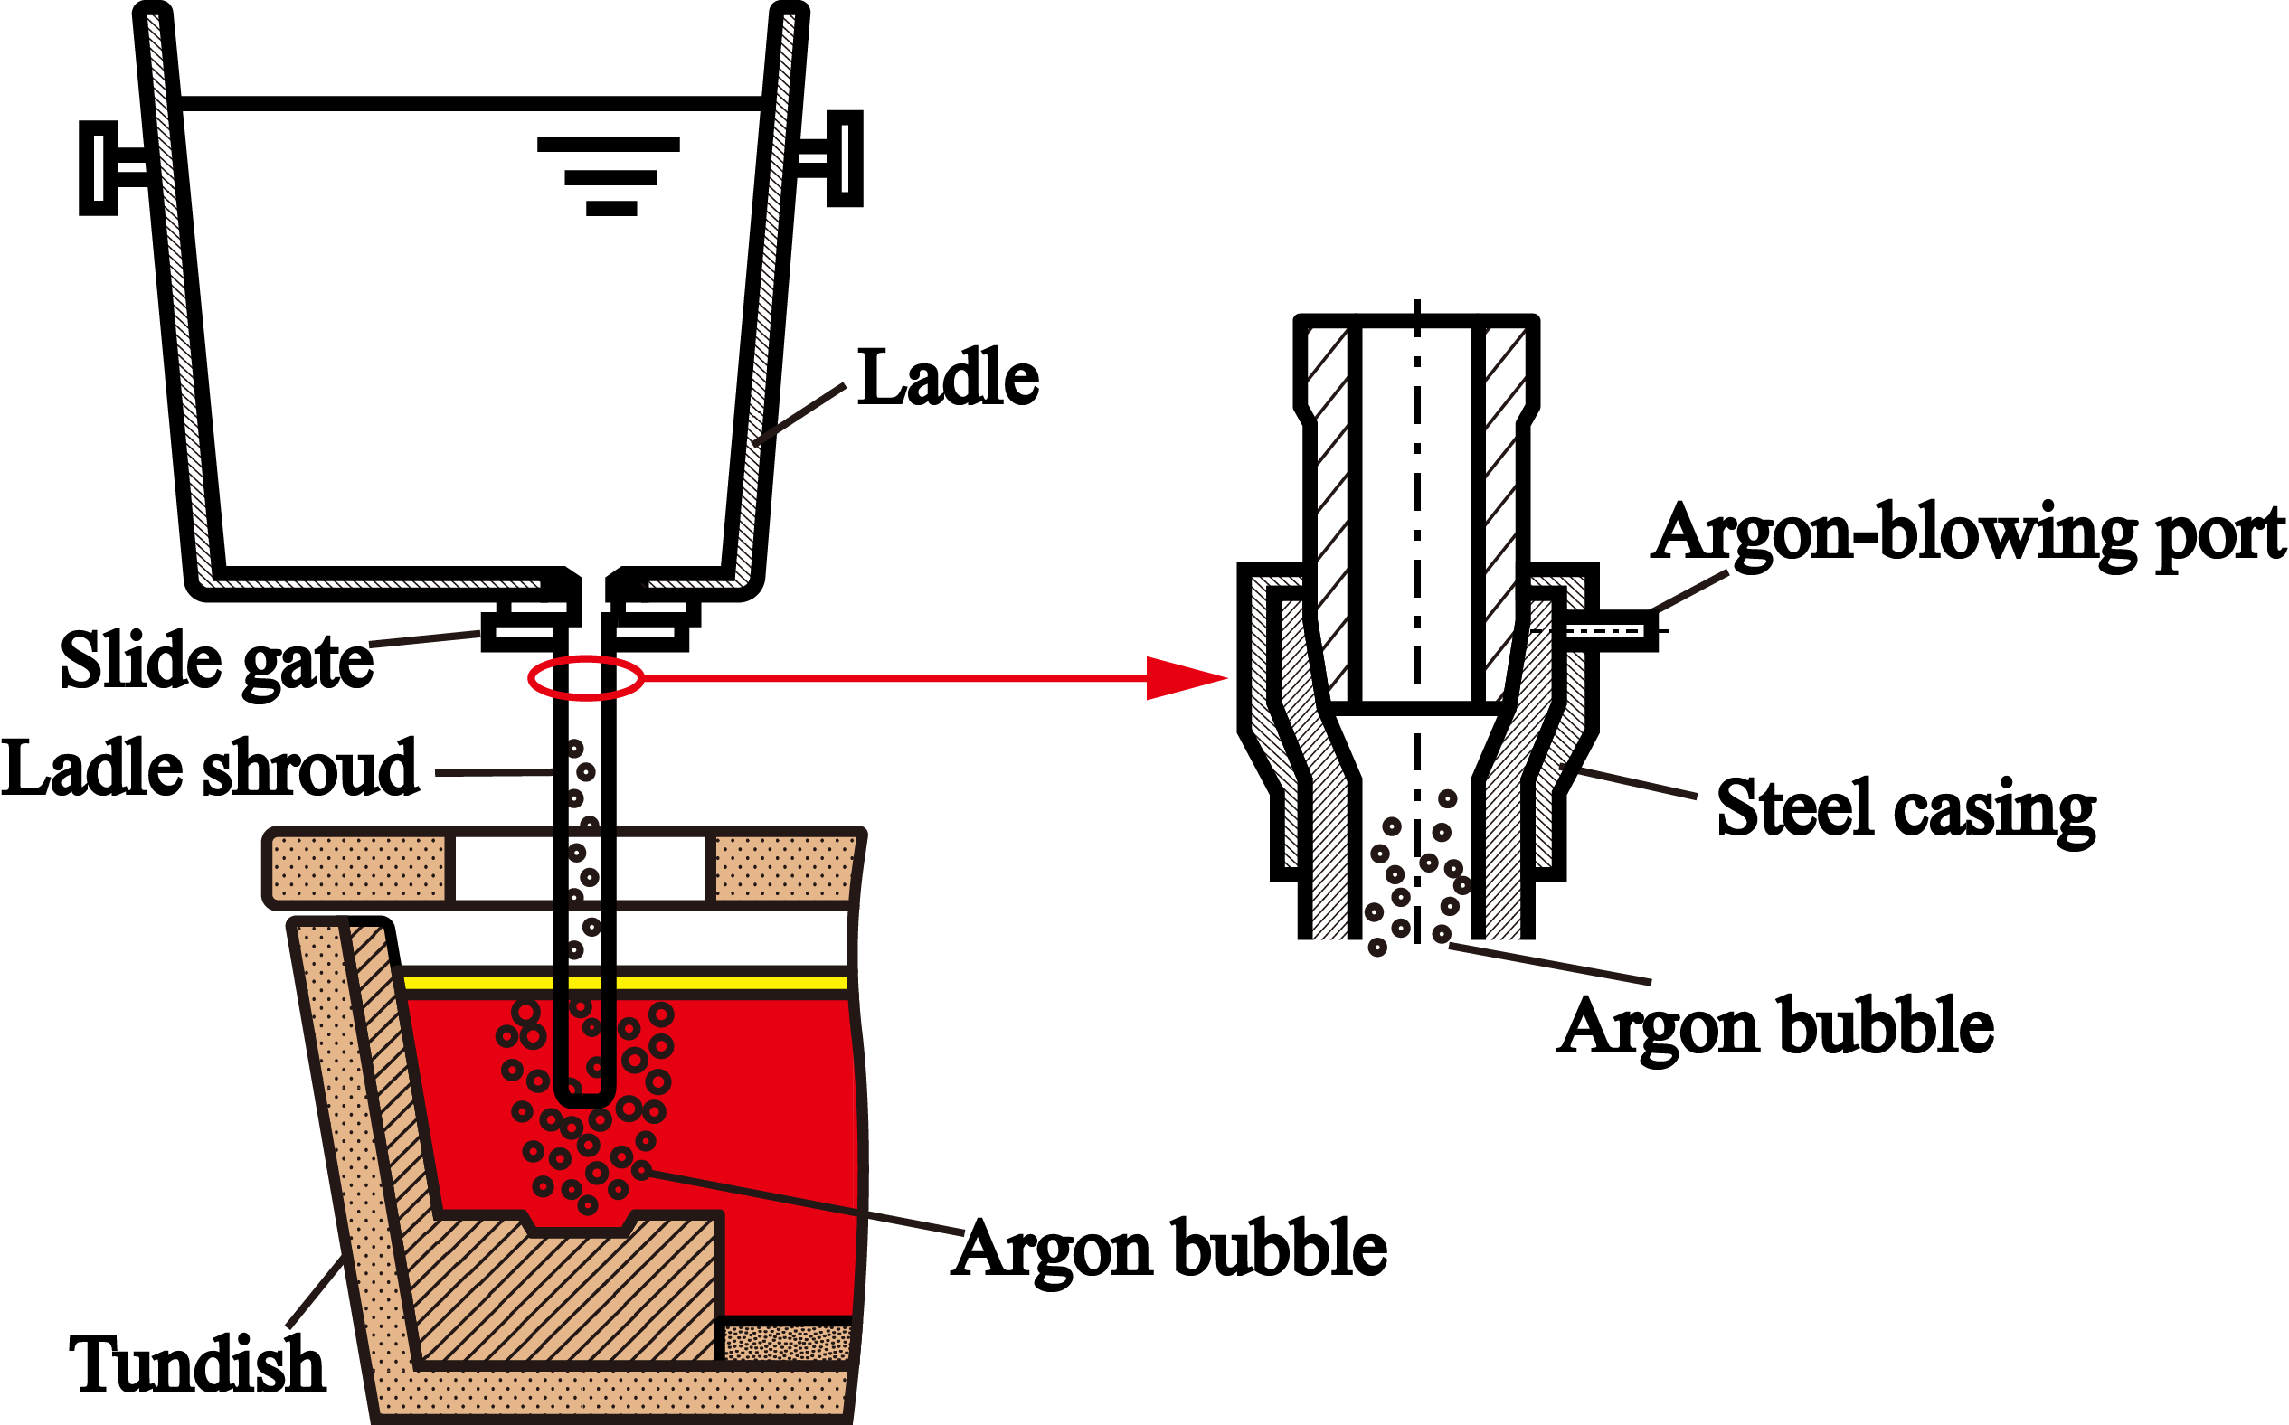
小五
黑体小五加粗
小五加粗
图1 连铸长水口保护浇注与吹氩保护装置示意图
Fig.1 Schematic diagram of protective casting using a ladle shroud and argon injection device
1.2 冷钢片沾钢法
本实验设计了“冷钢片沾取”捕捉现实生产中间包钢液中气泡的方法。具体方法是采用5 mm左右厚度冷钢片，插入长水口出口下方钢液中，停留5~10 s左右；利用冷钢片的冷却作用，使冷钢片周围钢液快速凝固冻结在冷钢片表面，在冷钢片表面形成钢壳；这些被冻结的钢液中原有气泡和夹杂物等也被原位快速冻结在钢壳中；快速上提冷钢片，对提取的气泡和夹杂物等进行检测分析（见图2）。
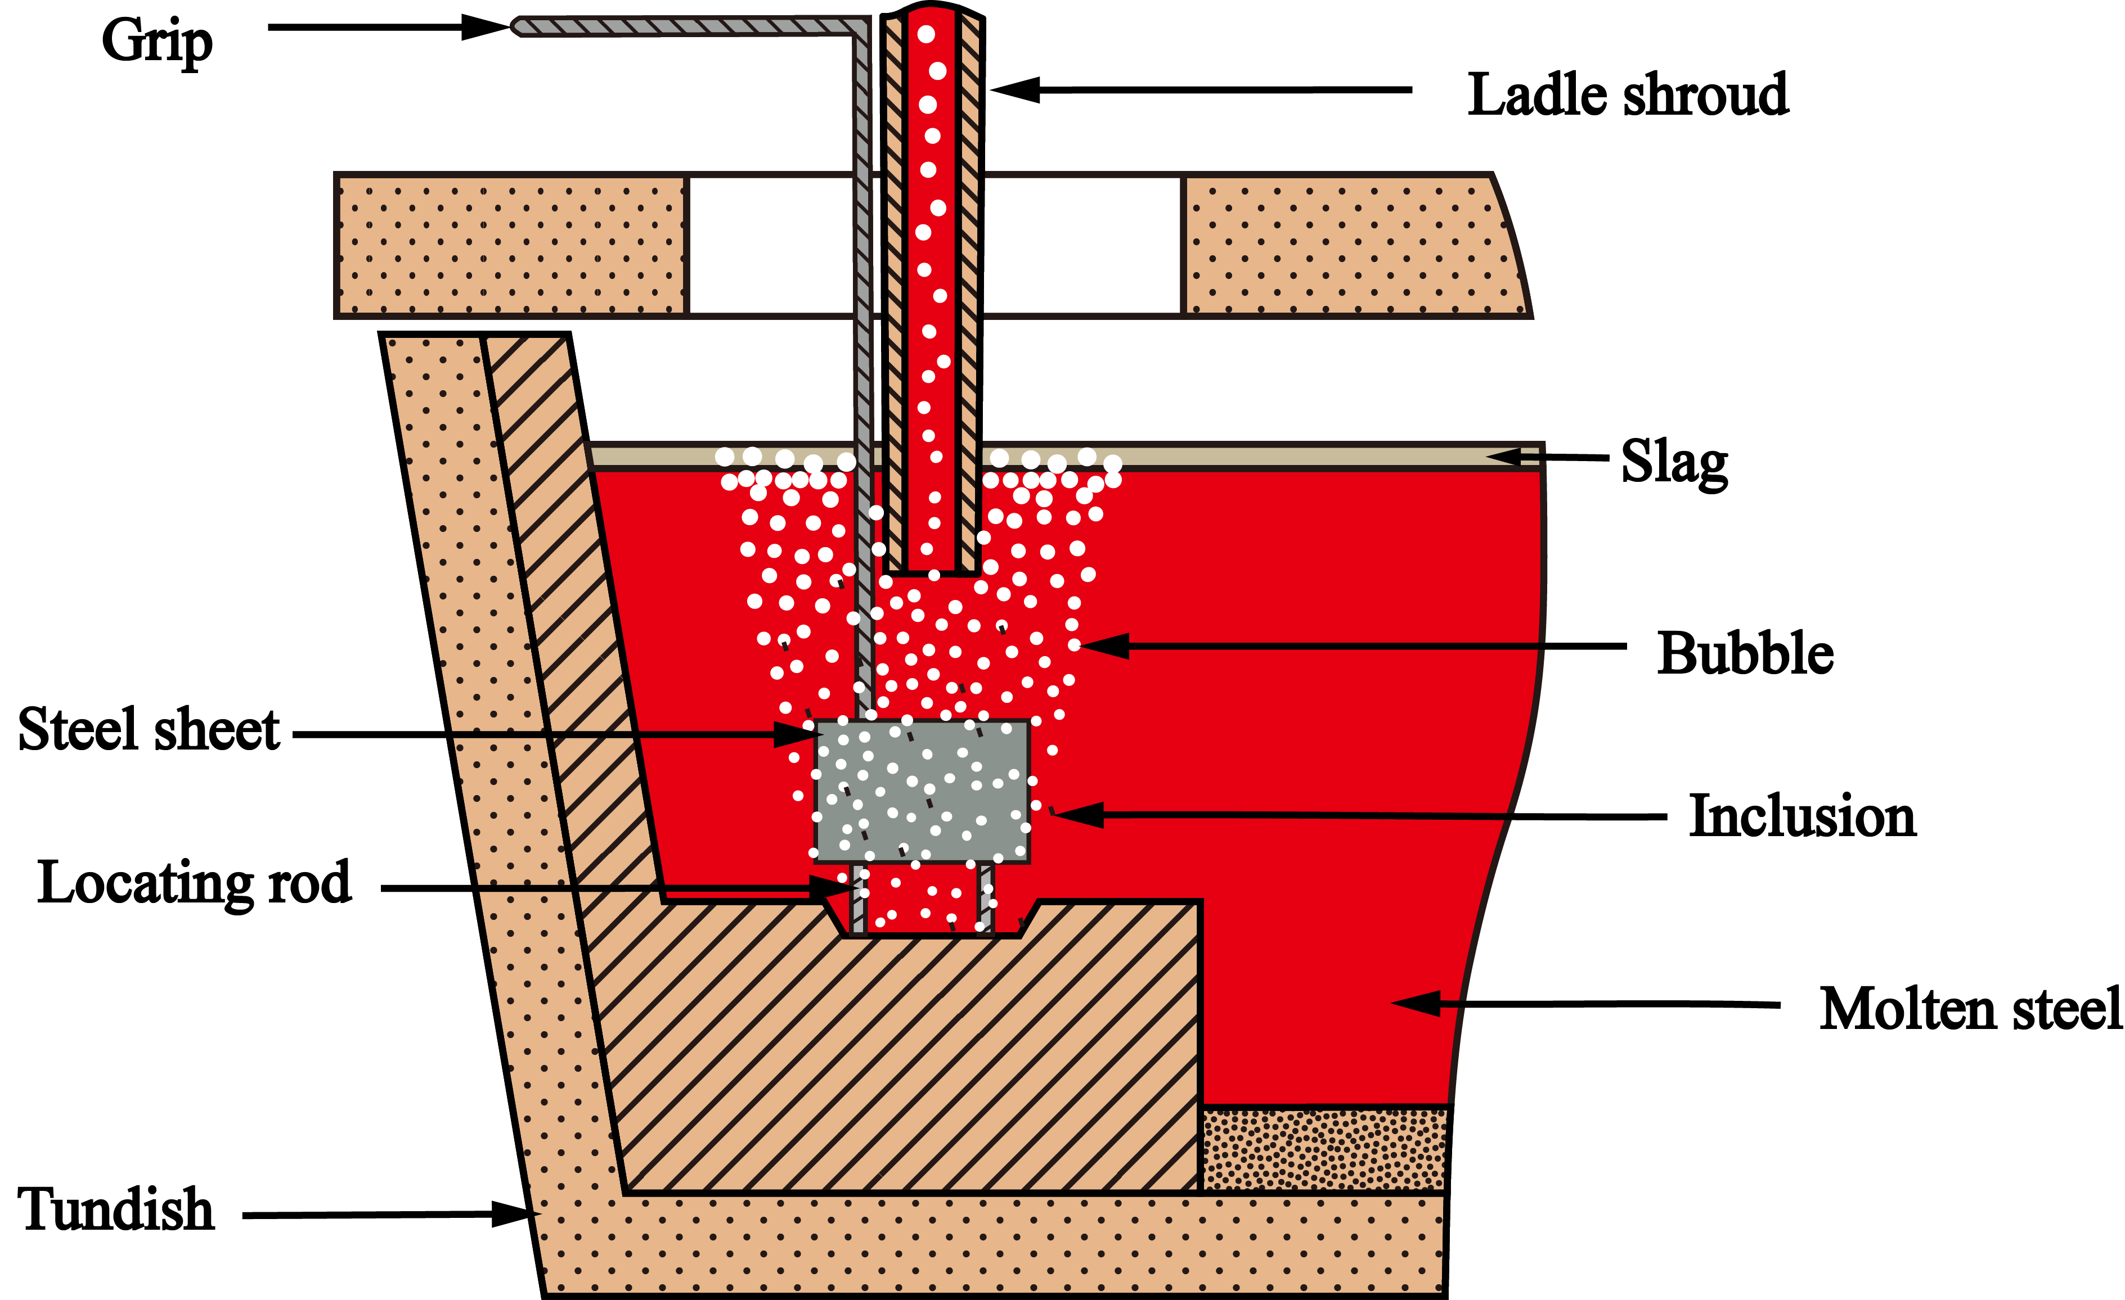
图2 冷钢片沾钢法示意图
Fig.2 Schematic diagram of dip sampling method using a cold steel sheet
2. 结果与讨论
黑体小五加粗
2.1 冷钢片沾取钢样表面气泡
上述3块沾取钢样表面气泡数量及尺寸统计结果如表1所示。
表1 冷钢片沾取试样表面气泡数量及平均尺寸
小五
小五加粗
Table 1 Number and average size of bubbles on the surface of a cold steel sheet
Number of steel sheet | 0-1.0 mm | 1.0–3.0 mm | 3.0–5.0 mm | 5.0–10.0 mm | Total | Average size/mm
1-vertical steel sheet | 0 | 37 | 19 | 4 | 60 | 3.12  六号
2-vertical steel sheet | 0 | 48 | 10 | 13 | 71 | 3.02
2-horizontal steel sheet | 0 | 28 | 5 | 0 | 33 | 2.13
由测量和统计结果可知，3块钢样在完全冷却前表面可观测的气泡大多为尺寸在1.0 ~3.0 mm的小气泡。3.0~5.0 mm和5.0~10.0 mm的气泡所占比例均较小；3块钢片表面所观测到的气泡平均尺寸均在3.0 mm左右。

2.2 冷钢片沾取钢样内部气泡
2.2.1激光共聚焦显微镜分析结果
图3中照片分别为实验第1和第2炉次实验沾取钢样内部气泡的共聚焦显微镜照片。由图可见，气泡在钢样中分布较为弥散。
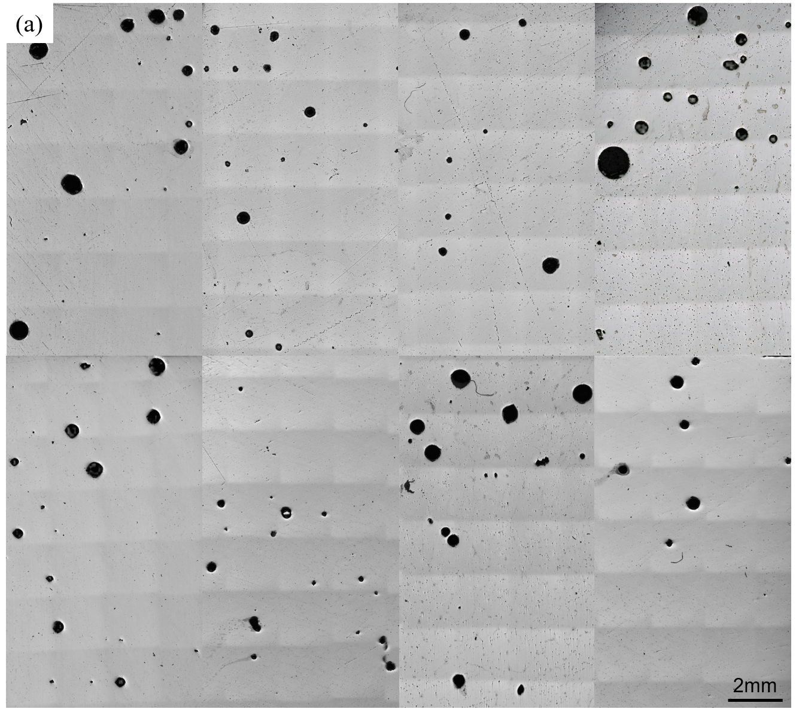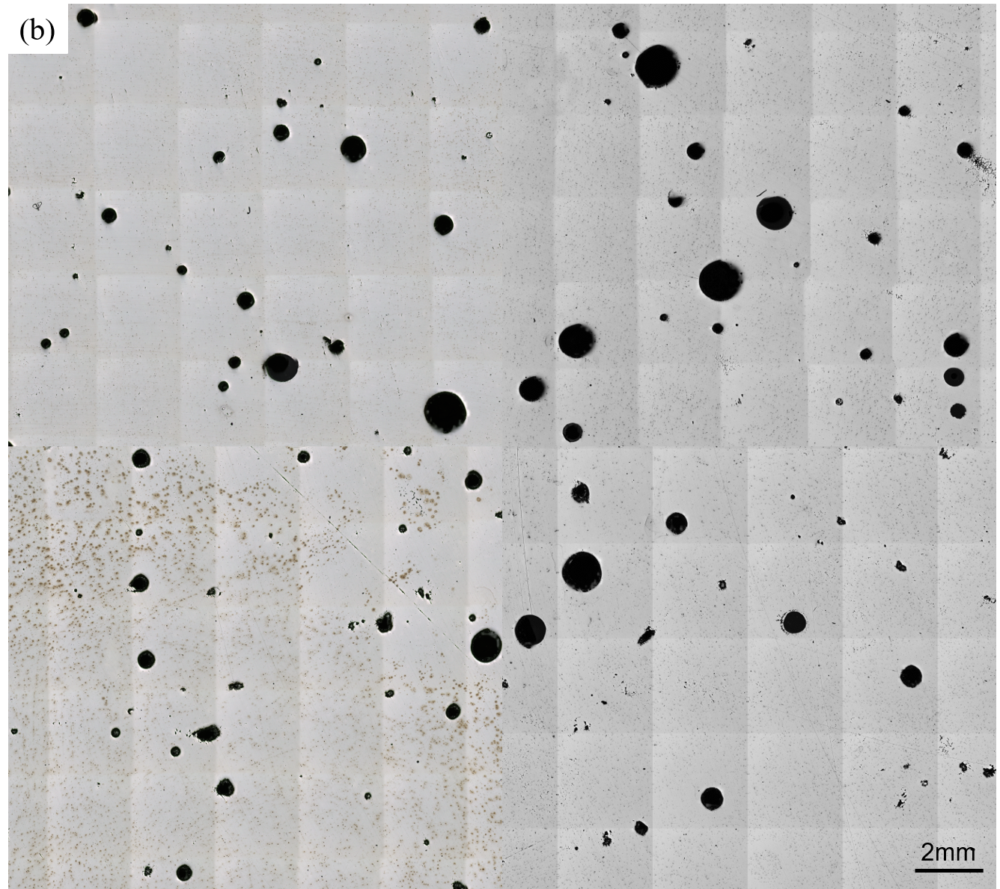
图3 冷钢片沾样内部气泡形貌. (a) 第1炉次; (b) 第2炉次
Fig.3 Shape of bubbles in a cold steel sheet: (a) the first test and (b) the second test
2.2.2扫描电镜观察结果
为了进一步深入分析沾取钢样内部气泡尺寸，采用扫描电镜对沾取钢样内部气泡进行了观察。图8和图9是部分气泡扫描电镜照片，由图可见，试样内部气泡基本呈球形，尺寸大都处于100~1000 μm，偶见直径小于100 μm和大于1000 μm气泡；大部分气泡为单个独立气泡。
137.80 μm
170.57 μm
200.16 μm
56.49 μm
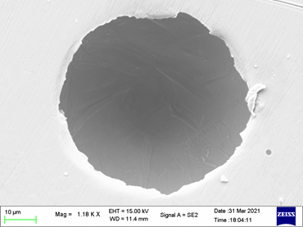
347.50 μm
319.98 μm
250.10 μm
396.23 μm
图8 冷钢片沾取试样中单个球形气泡形貌及直径尺寸
Fig.8 Shape and size of single spherical bubble in a cold steel sheet
2.3 气泡捕捉夹杂物行为
通过扫描电镜结合能谱分析，发现在中间包冷钢片沾样内部气泡中部分气泡粘附有夹杂物，图14是部分气泡粘附夹杂物的照片和夹杂物成分能谱分析结果。其中部分气泡粘附有多个夹杂物。
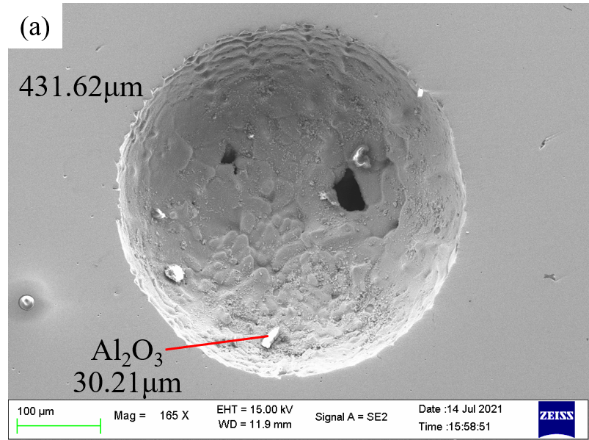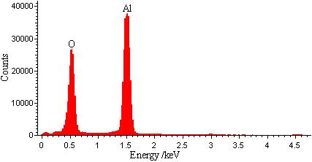
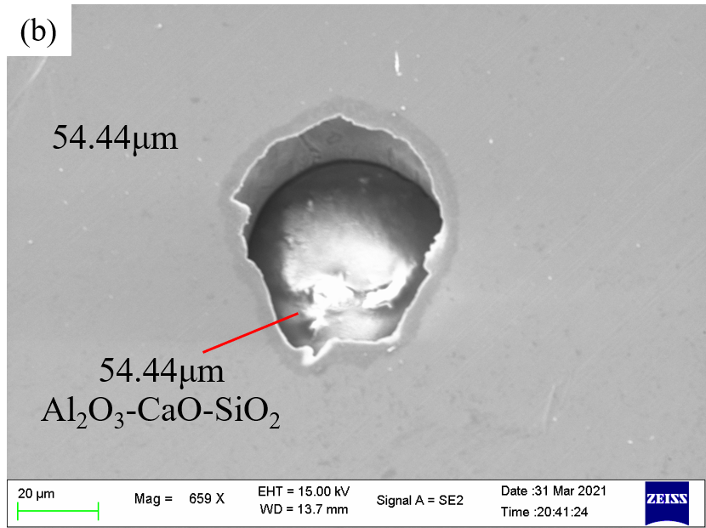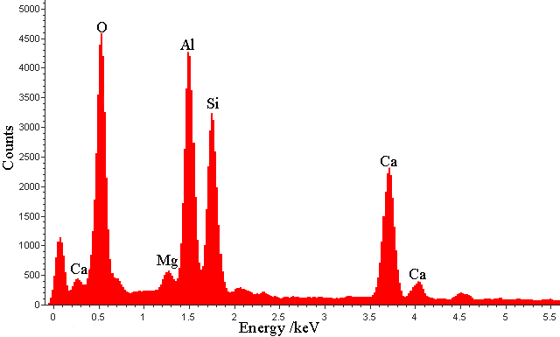
图14 气泡粘附夹杂物和夹杂物成分能谱分析结果. (a)粘附Al₂O₃夹杂; (b)粘附CaO‒Al₂O₃‒SiO₂复合夹杂
Fig.14 Bubbles adhere to inclusions and inclusion composition: (a) Al₂O₃; (b) CaO‒Al₂O₃‒SiO₂

3结论
(1) 连铸生产中采用大流量长水口吹氩，可在中间包钢液内部产生弥散微小氩气泡，该类氩气泡可捕捉钢中夹杂物，促进夹杂物上浮去除。
(2) 采用冷钢片沾钢法可成功沾取中间包钢液微小氩气泡，沾样内部气泡为长水口吹氩在中间包钢液中生成的微小氩气泡，本实验条件下生成的气泡尺寸主要介于100~1000 μm，平均尺寸为500 μm左右。
(3) 湍动能破碎气泡理论解释长水口吹氩生成微小气泡生成机理较为合理；但长水口长度有限，气泡在长水口中没有充分破碎，钢铁生产中长水口吹氩生成微小气泡尺寸理论计算还需深入研究。

参考文献
等线五号
[1] Liu J H, Zhang J, Li K W. Current state and prospect of technologies for removing inclusion by bubbles. Steelmaking, 2017, 33(2): 1
小五
(刘建华, 张杰, 李康伟. 气泡去除夹杂物技术研究现状及发展趋势. 炼钢, 2017, 33(2): 1)
[2] Liu W J, Lee J, Guo X P, et al. Argon bubble coalescence and breakup in a steel ladle with bottom plugs. Steel Res Int, 2019, 90(4): 1800396
[3] Sutherland K L. Physical chemistry of flotation. XI. kinetics of the flotation process. J Phys Chem, 1948, 52(2): 394

基金项目：国家自然科学基金资助项目(51874028)

