Asia Water Council

17-18th Board of Council Meetings & 4th General Assembly
& 3rd AIWW Kick-off Meeting

Songsan, Republic of Korea / 5-8 July 2023

Venue

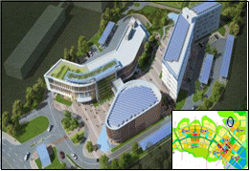 | Songsan Global Education Center  (Address) 883, Gongnyong-ro, Songsan-myeon, Hwaseong-si, Gyeonggi-do, Republic of Korea  (Facility) Total floor area 16,856.72㎡  - Education Center (3rd floor)  - Auditorium/Restaurant (2nd floor)  - Dormitory (5th floor)

Accommodations

For your convenience, AWC Secretariat recommends two (2) main hotels near Venue, please make your own reservation through the website link as below.

(*There is no funding support for participants, such as flight tickets and lodging)

No. | Main Hotels | Image
1 | Songdo Central Park Hotel (★★★★)  193, Techno park-ro, Yeonsu-gu, Yeonsu-gu, 22004 Incheon, South Korea  http://www.centralparkhotel.co.kr/centralpark/ | 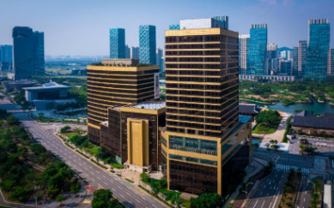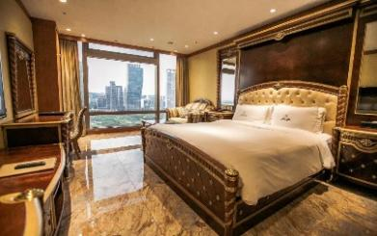
2 | Orakai Songdo Park Hotel (★★★★)  151, Techno park-ro, Yeonsu-gu, Incheon  https://songdo.orakaihotels.com/eng/default.asp | 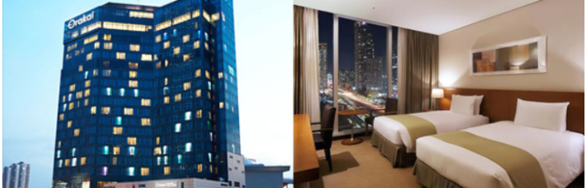

In addition to the above two hotels, there are several other star accommodation options nearby. Please make a reservation according to your preference.

Asia Water Council

17-18th Board of Council Meetings & 4th General Assembly
& 3rd AIWW Kick-off Meeting

Songsan, Republic of Korea / 5-8 July 2023

Transportation

During the event period (5-8 July, 2023), regular transportation will be operated between
accommodations and the venue including the (Incheon) airport pick-up service.
(*Accommodations (spots): Near the main hotels listed above)

*The detailed schedules of transportation service will be announced later.

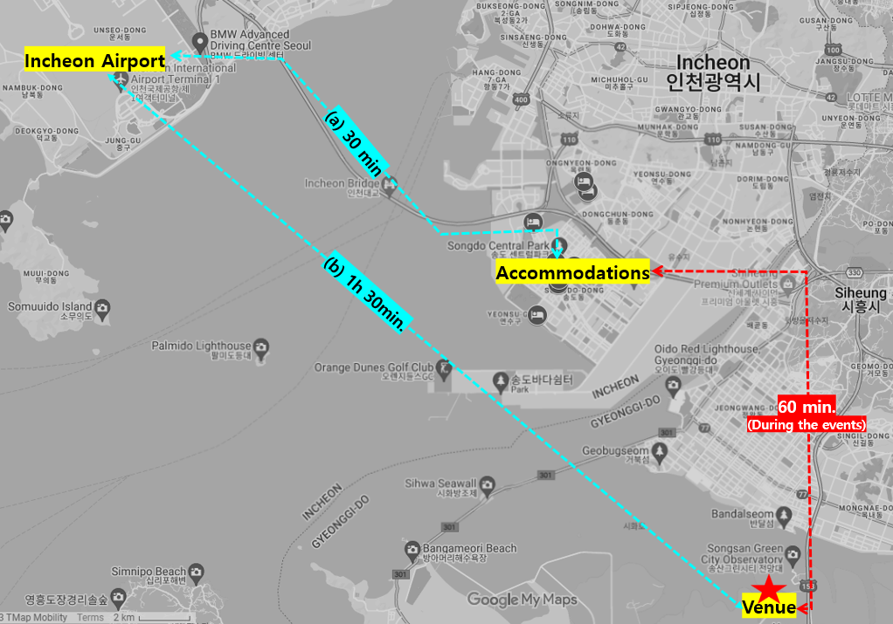

Asia Water Council

17-18th Board of Council Meetings & 4th General Assembly
& 3rd AIWW Kick-off Meeting

Songsan, Republic of Korea / 5-8 July 2023

Visa

Entering Korea have different entry conditions depending on international agreements or relationships between countries.

Before purchasing a plane ticket to Korea, please make sure to visit the Korean visa portal site and search for the conditions that apply to you.
https://www.visa.go.kr/openPage.do?MENU_ID=10101

Letter of Invitation
An official invitation letter is intended to help potential attendees raise funds or obtain visas. It is not a commitment on the part of the organizers to provide any financial support.
AWC Secretariat cannot intervene with Korea Embassies abroad on behalf of any participant. But if you need an individual invitation personally, please contact the AWC secretariat. (awc@asiawatercouncil.org)

K-ETA (Korea Electronic Travel Authorization)

K-ETA Application Eligibility

Visa-waiver & Visa-free entry countries/regions (Total 107 countries) | Neither Visa-waiver nor Visa-free entry countries/regions | Already have valid visa of valid K-ETA  (Validity 2 years, multiple entry)
MUST obtain K-ETA | MUST obtain Visa | Don’t need to obtain K-ETA
- Foreign visitors who do not require a visa must obtain a K-ETA permit to board a flight bound for Korea.
- Please apply at least 72 hours before departure by accessing the K-ETA website or mobile app (K-ETA) (as assessment can take "more than 72 hours" depending on the situation).
- K-ETA is valid for two years after issuance, and the number of arrivals is irrelevant. However, if the validity period of the passport is within two years when applying for K-ETA, the K-ETA is valid only until the validity period of the passport.
(K-ETA is not a visa. The issuance of K-ETA does not guarantee the entry of the Republic of Korea, and the entry availability of Korean immigration officials is finally determined according to the results of the immigration inspection.)

From Apply to Entering Korea
(Step 1) Access the K-ETA website (https://www.k-eta.go.kr/portal/apply/viewstep1.do)
(Step 2) Input after checking the contents for each category
(Step 3) Make payment (KRW 10,000, approximately USD $9~10, additional fee excluded)
(Step 4) Under assessment (Within 72 hours)
(Step 5) Check results
(Step 6) Entry (Don’t need to print or bring the ‘K-ETA’ and ‘e-Arrival Card’. Also don’t need to submit the Arrival Card.)

