A New Proportion of Levofloxacin Citrate and Its Impact on the Solubility, Stability, and Potency
Ilma Nugrahani ^{1,}*, Agnesya N. Laksana ¹, Hidehiro Uekusa ², Hironaga Oyama ², Maria Singgih Wibowo ¹
¹ School of Pharmacy, Bandung Institute of Technology, West Java 40132, Indonesia; agnesyanamira@gmail.com (A.N.L.)
² Department of Chemistry, School of Science, Tokyo Institute of Technology, Tokyo 152-8551, Japan; uekusa@chem.titech.ac.jp (H.U.)
* Correspondence: ilma_nugrahani@fa.itb.ac.id (I.N.)
Abstract: We recently reported a new salt organic compound derived from levofloxacin (LF) base with citric acid (CA) in the 1:1 molar ratio, enhancing the LF’s stability and potency. Furthermore, considering the side effect of CA on the gastrointestinal tract, in this present research, we reduced the CA dose. A new molar ratio, 2:1, was prepared by solvent-dropped grinding and slow evaporation. Next, the salt formation was confirmed by thermal analysis, X-ray diffractometry, and vibrational spectrophotometry. Single-crystal X-ray diffractometry determined the final structure of the new salt. Next, stability, solubility, and potency tests were performed to investigate the advantage of this new composition of levofloxacin citrate. As a result, levofloxacin-citrate (2:1) - 4.5-hydrate was successfully isolated, characterized, and determined. Like the (1:1) molar ratio reported before, this new salt also improves the chemical stability, solubility 1-2 times, and potency of LF towards Staphylococcus aureus and Escherichia coli 1.5-2 times. Hence, this new composition can be considered a new candidate for antibiotic-antioxidant preparation, which is more efficient and safer than the previous molar ratio.
Keywords: levofloxacin, citric acid, salt, stability, solubility, potency.

Graphical Abstract

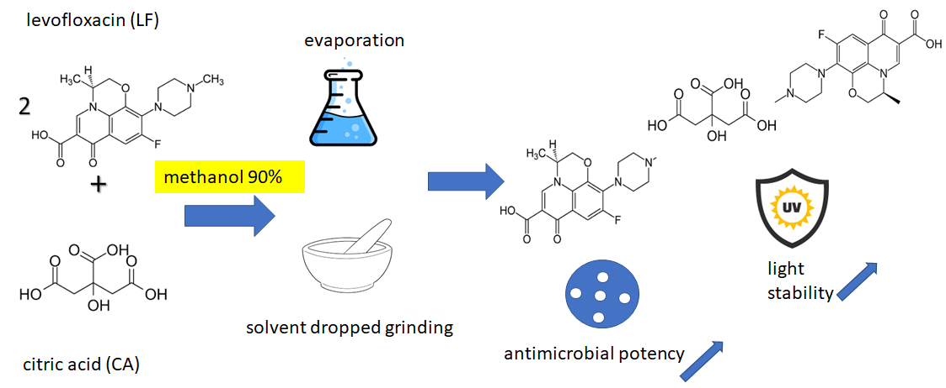

References:
- Nugrahani, I.; Laksana, A.N.; Uekusa, H.; Oyama, H. New organic salt from levofloxacin-citric acid: what is the impact on the stability and antibiotic potency? Molecules 2022, 27(7), 2166.
- Nugrahani I, Sulaiman MR, Eda C, Uekusa H, Ibrahim S. Stability and Antibiotic Potency Improvement of Levofloxacin by Producing New Salts with 2,6- and 3,5-Dihydroxybenzoic Acid and Their Comprehensive Structural Study. Pharmaceutics. 2023; 15(1):124. https://doi.org/10.3390/pharmaceutics15010124.

