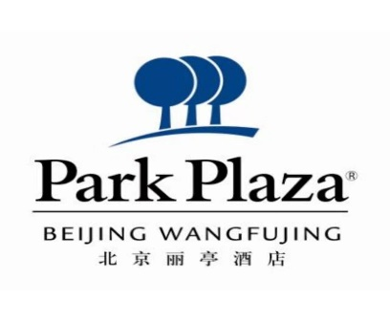

**Human Genetics and Genomics:**

**maximizing power to address complexity and human health.**

Reservation Form

|  |  |  |  |  |
| --- | --- | --- | --- | --- |
| **Guest Details** | | | | |
| Guest Name | | |  | |
| Email | | |  | |
| Number of rooms | | |  | |
| Gender | | | Male | Female |
| Arrival Date | | |  | |
| Departure Date | | |  | |
| Check in time: 2pm | | | Check out time: 12pm | |
| Credit Card Number | | |  | |
| Expire Date | | |  | |
| **No.** | **Room Type and Room Rate** | | | |
| 1 | **Deluxe King Room** | RMB**850** / include one BF | | |
| 2 | **Deluxe Twin Room** | RMB**950** / include two BF | | |
| **Rate** : The above rates inclusive of service charge and VAT. | | | | |

**Terms and Conditions：**

1. Please fill in this reservation form and send to ：[reservation@parkplaza-beijing.com](mailto:reservation@parkplaza-beijing.com).

CC [kevin.zhang@regent-beijing.com](mailto:kevin.zhang@regent-beijing.com) and [claire.huo@regent-beijing.com](mailto:claire.huo@regent-beijing.com)

1. If you need to book the room, please reply to us before **16th of Sep**, if beyond this time, we cannot guarantee the room can be reserved with this room rate.
2. Any cancellation after **23th of Sep** will result in first night room charge for each room cancelled.

This will be charged to your credit card.