Title of the Abstract

Author (initial surname)¹, Second Author (initial surname) ², Corresponding Author (initial surname)^{1,}*

¹Department of Chemistry, University of xxxxxx, Postal address, City, Post code
²Institut of Chemistry, Chinese Academy of Sciences, Postal address, City, Post code

e-mail : xxx@nankai.edu.cn

Abstract text in English, Times New Roman, 150 words maximum, single space.
Figure size 140 x 40 maximum.

Graphic Abstract (Insert TOC Graphic here)
Fig. 1 Figure title

References
- Surname, A.; Surname, B.-C.; Surname, D.-E. J .Org. Chem. 2019, 37, xxxx.
2.
3.

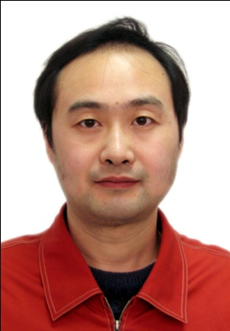
Chao Chen, Ph.D.
1997-2001, B.S. in Chemistry, Tsinghua University, China
2001-2006, Ph.D in Chemistry, Tsinghua University, China
2007-2008, Humboldt Fellowship, Muenster University
2009-2011, Postdoc. Muenster University
2011- Associate Professor in Chemistry, Tsinghua University
Honours and awards：CCS Young Chemist Award (2014), Thieme Chemistry Journal Award (2015), Yangtze Scholarship for Youth (2019)
Research interests：Organo-Element Chemistry, Organic Synthesis

